
INFORMATION COMMUNICATION AND TECHNOLOGY UNIVERSITY
(ICT-U)
Yaoundé, Cameroon

Project Report
DESIGN AND IMPLEMENTATION OF A SECURE ELECTRONIC HEALTH RECORD SYSTEM WITH BLOCKCHAIN INTEGRITY VERIFICATION AND ROLE-BASED ACCESS CONTROL
A dissertation presented and submitted in partial fulfillment of the requirement for the degree of a
Bachelor of Science in CYBERSECURITY (BSc)
By
YONG PAOLA NABAIN
(ICTU20234457)
Supervised by:
Dr. FOSSO CAROLE

Academic Year: 2025/2026

DECLARATION
I declare that the work entitled “Design and Implementation of a Secure Electronic Health Record System with Blockchain Integrity Verification and Role-Based Access Control” is my own original work, conceived and presented in the partial fulfillment of the requirement for the degree of a Bachelor of Science in Cyber Security at the ICT University. This work has not been submitted for any degree or examination in any other university, and all the sources I have used or quoted have been indicated and acknowledged as complete references.

Name: YONG PAOLA NABAIN

Registration Number: ICTU20234457

Signed: _______________________

Date: _______________________

CERTIFICATION
This work entitled “Design and Implementation of a Secure Electronic Health Record System with Blockchain Integrity Verification and Role-Based Access Control” has been submitted for examination with my approval as the Research Supervisor.

Signed: _______________________

Date: _______________________

Name: Dr. FOSSO CAROLE

DEDICATION
This work is dedicated to my family, especially my Dad, Mum and Aunty Ben, whose unfailing support and encouragement have sustained me throughout my studies; and to SHADE ROOM, whose friendship, motivation and unwavering support reminded me, in every difficult moment, why this work was worth finishing.

ACKNOWLEDGEMENTS
This endeavor would not have been possible without the strength and grace of the Almighty God. I extend my sincere gratitude to my supervisor for the guidance, patience and constructive criticism that shaped this work. I am grateful to the lecturers and staff of the Faculty of Information and Communication Technology at ICT University for the knowledge and skills imparted to me. And I am deeply indebted to my family and friends for their constant encouragement and support throughout the course of this study.

FACULTY APPROVAL
This dissertation has been duly reviewed by the Department and the Faculty and is ready for examination with our approval.

Approved by

Signature: ____________________________ Date: ______________
Dr. FOSSO CAROLE
Supervisor

Signature: ____________________________ Date: ______________
Dr. NKANDEU PASCAL
Dean, ICT Faculty

TABLE OF CONTENTS
DECLARATION ii
CERTIFICATION iii
DEDICATION iv
ACKNOWLEDGEMENTS v
FACULTY APPROVAL vi
ABSTRACT vii
RÉSUMÉ viii
LIST OF TABLES xii
LIST OF FIGURES xiii
LIST OF ACRONYMS AND ABBREVIATIONS xiv
CHAPTER ONE: INTRODUCTION 1
1.1 Background to the Problem 1
1.2 Statement of the Problem 3
1.3 Objectives of the Study 5
1.3.1 General Objective 5
1.3.2 Specific Objectives 5
1.4 Research Questions 5
1.5 Scope of the Study 6
1.6 Significance of the Study 6
1.7 Limitations of the Study 7
1.8 Organization of the Study 8
CHAPTER TWO: LITERATURE REVIEW 9
2.1 Introduction 9
2.2 Conceptual Review of Electronic Health Records 9
2.3 Privacy, Confidentiality and Security in Electronic Health Records 11
2.4 Data Protection Regulation and Compliance 12
2.5 Cryptographic Foundations of Data Integrity and Confidentiality 13
2.6 Blockchain Technology: Concepts and Architecture 14
2.7 Blockchain for Integrity Verification in Electronic Health Records 15
2.8 Access Control Models and Role-Based Access Control 17
2.9 Authentication and Identity Management in Health Information Systems 19
2.10 Review of Related Systems 19
2.11 Challenges and Open Issues in Blockchain-Based EHRs 21
2.12 Electronic Health Records in the African and Cameroonian Context 22
2.13 Theoretical Framework 23
2.14 Summary and Research Gap 24
CHAPTER THREE: METHODOLOGY 26
3.1 Introduction 26
3.2 Research Design 26
3.3 Requirements Gathering 27
3.4 Population and Sample 28
3.5 System Development Methodology 29
3.6 System Analysis and Design Tools 30
3.7 Development Tools, Technologies and Techniques 31
3.8 Quantitative Analysis and Evaluation Metrics 33
3.9 Testing Strategy 34
3.10 Ethical Considerations 34
3.11 Summary 35
CHAPTER FOUR: ANALYSIS, DESIGN, IMPLEMENTATION AND FINDINGS 36
4.1 Introduction 36
4.2 Analysis of Gathered Requirements 36
4.3 System Design 43
4.4 System Implementation 50
4.5 System Testing 56
4.6 Findings and Results 57
4.7 Summary 59
CHAPTER FIVE: SUMMARY, CONCLUSIONS, DISCUSSION AND RECOMMENDATIONS 60
5.1 Summary of the Study 60
5.2 Conclusions 61
5.3 Discussion 62
5.4 Recommendations 63
5.5 Concluding Remarks 63
REFERENCES 65

LIST OF TABLES
Table 2.1: Comparison of major access-control models 17
Table 2.2: Summary of selected related blockchain-based EHR systems 20
Table 3.1: Target population and sample distribution 29
Table 3.2: Roles and access permissions in the proposed system 32
Table 3.3: Development tools and technologies 32
Table 3.4: Evaluation metrics for the prototype 33
Table 4.1: Functional requirements by role 42
Table 4.2: Non-functional requirements of the system 43
Table 4.3: Core database tables and their purpose 50
Table 4.4: Smart contracts and their responsibilities 52
Table 4.5: Representative access-control test cases and outcomes 57
Table 4.6: Integrity (tamper-detection) test cases and outcomes 57
Table 4.7: Performance measurements of the prototype 58
Table 4.8: Usability evaluation results (n = 30) 59

LIST OF FIGURES
Figure 2.1: Basic structure of a blockchain showing hash-linked blocks 14
Figure 3.1: Iterative and incremental development methodology adopted for the study 29
Figure 3.2: High-level architecture of the proposed secure EHR system 31
Figure 4.1: Respondent satisfaction with current medical-records management 37
Figure 4.2: Respondents whose records had been kept electronically 37
Figure 4.3: Respondents who felt their information had been shared without permission 38
Figure 4.4: Importance respondents place on records being kept private and secure 38
Figure 4.5: Respondents who would feel safer with encrypted records 39
Figure 4.6: Respondent views on patient control over record access 39
Figure 4.7: Respondent preferences for notification when records are viewed 40
Figure 4.8: Information respondents would permit doctors to access in an emergency 40
Figure 4.9: Respondent views on time-limited emergency access 41
Figure 4.10: Features respondents would most want in an EHR system 41
Figure 4.11: Use case diagram of the Secure EHR System (VitaSecure) 44
Figure 4.12: Component diagram of the Secure EHR System 45
Figure 4.13: Class diagram (domain model) of the Secure EHR System 46
Figure 4.14: Sequence diagram — doctor creates a clinical encounter 47
Figure 4.15: Sequence diagram — record retrieval with access control 48
Figure 4.16: Sequence diagram — record integrity verification 48
Figure 4.17: Sequence diagram — laboratory order-to-result workflow 49
Figure 4.18: VitaSecure clinician login screen 51
Figure 4.19: Administrator console 53
Figure 4.20: Doctor dashboard 54
Figure 4.21: Nursing dashboard 54
Figure 4.22: Laboratory technician queue 55
Figure 4.23: Receptionist front desk 55
Figure 4.24: Patient health record portal 56

LIST OF ACRONYMS AND ABBREVIATIONS
ABAC Attribute-Based Access Control
AES Advanced Encryption Standard
API Application Programming Interface
CIA Confidentiality, Integrity and Availability
DAC Discretionary Access Control
EHR Electronic Health Record
EMR Electronic Medical Record
EVM Ethereum Virtual Machine
HIPAA Health Insurance Portability and Accountability Act
IoT Internet of Things
MAC Mandatory Access Control
NIST National Institute of Standards and Technology
RBAC Role-Based Access Control
REST Representational State Transfer
RLS Row-Level Security
RPC Remote Procedure Call
SHA Secure Hash Algorithm
SQL Structured Query Language
TAM Technology Acceptance Model
UI User Interface
UML Unified Modeling Language

ABSTRACT
Electronic health records improve the safety and continuity of care but, in their conventional centralized form, they concentrate trust in a single custodian and a single database, leaving patient data vulnerable to unauthorized modification, undetected falsification and large-scale breach; in 2023 alone more than one hundred and thirty million health records were exposed worldwide. This study addresses the problem by designing and implementing a secure electronic health record system that integrates blockchain-based integrity verification with role-based access control. Following a design-science methodology, requirements were gathered through document review, interviews, questionnaires and observation within a medical-office setting, and the system was developed using an iterative and incremental approach with prototyping. The architecture stores encrypted records off-chain while anchoring their SHA-256 hashes on a permissioned blockchain through smart contracts, so that any alteration of a record is immediately detectable, and it confines every operation to the permissions of the user's organizational role through a role-based access-control engine. The artefact is evaluated quantitatively for its tamper-detection rate, its prevention of unauthorized access, its verification and commit performance, and the usability perceived by healthcare users. The evaluation found that the implemented prototype, named VitaSecure, enforced role-based access without exception across the tested scenarios, detected every deliberately introduced alteration to a record, and was received favorably by the users who assessed it, indicating that the approach is practical in a resource-constrained setting. On this basis the study recommends the adoption of off-chain storage with on-chain hash anchoring and smart-contract-enforced role-based access control as a practical model for trustworthy digital health records, and it recommends further study extending the prototype to multi-facility deployment and live clinical evaluation. The work contributes an implemented and evaluated artefact to a literature dominated by conceptual proposals and situates that contribution explicitly within the Cameroonian context.
Keywords: electronic health records; blockchain; data integrity; role-based access control; smart contracts; healthcare data security.

RÉSUMÉ
Les dossiers de santé électroniques améliorent la sécurité et la continuité des soins mais, sous leur forme centralisée classique, ils concentrent la confiance dans un seul dépositaire et une seule base de données, exposant les données des patients à la modification non autorisée, à la falsification non détectée et aux violations à grande échelle; rien qu'en 2023, plus de cent trente millions de dossiers de santé ont été exposés dans le monde. Cette étude répond à ce problème en concevant et en mettant en œuvre un système sécurisé de dossiers de santé électroniques qui intègre la vérification de l'intégrité fondée sur la chaîne de blocs et le contrôle d'accès basé sur les rôles. Suivant une méthodologie de science de la conception, les besoins ont été recueillis au moyen de l'examen documentaire, d'entretiens, de questionnaires et de l'observation, et le système a été développé selon une approche itérative et incrémentale avec prototypage. L'architecture stocke les dossiers chiffrés hors chaîne tout en ancrant leurs empreintes SHA-256 sur une chaîne de blocs à accès restreint au moyen de contrats intelligents, de sorte que toute altération d'un dossier soit immédiatement détectable, et elle restreint chaque opération aux permissions du rôle organisationnel de l'utilisateur grâce à un moteur de contrôle d'accès basé sur les rôles. L'évaluation a révélé que le prototype mis en œuvre, nommé VitaSecure, a appliqué le contrôle d'accès basé sur les rôles sans exception dans tous les scénarios testés, a détecté chaque altération délibérément introduite dans un dossier, et a été bien accueilli par les utilisateurs qui l'ont évalué, ce qui indique que l'approche est pratique dans un contexte à ressources limitées. Sur cette base, l'étude recommande l'adoption du stockage hors chaîne avec ancrage des empreintes sur la chaîne et du contrôle d'accès basé sur les rôles appliqué par contrats intelligents comme modèle pratique pour des dossiers de santé numériques dignes de confiance, et elle recommande des recherches complémentaires étendant le prototype au déploiement multi-établissements et à l'évaluation clinique réelle. Ce travail apporte un artefact mis en œuvre et évalué à une littérature dominée par des propositions conceptuelles et situe explicitement cette contribution dans le contexte camerounais.
Mots-clés : dossiers de santé électroniques; chaîne de blocs; intégrité des données; contrôle d'accès basé sur les rôles; contrats intelligents; sécurité des données de santé.

CHAPTER ONE: INTRODUCTION

1.1 Background to the Problem
The integrity and confidentiality of patient health information have become decisive factors in the safe and effective delivery of modern healthcare. Healthcare organizations are progressively abandoning fragmented paper-based filing in favor of electronic health record (EHR) systems that consolidate a patient's clinical and administrative information into a single longitudinal record that can be retrieved, updated and shared by authorized clinicians. An electronic health record differs from an electronic medical record (EMR) in that the EMR is confined to the documentation of a single provider, whereas the EHR aggregates a patient's data across multiple facilities and care episodes, supporting continuity of care, clinical decision support and population health management (Keshta & Odeh, 2021). This consolidation is precisely what makes the EHR valuable, and at the same time it is what makes the EHR an attractive and high-value target for malicious actors.
Health information is among the most sensitive categories of personal data because it cannot be reissued or replaced in the way that a compromised bank card can. Once a diagnosis, a genetic profile or a treatment history is exposed, the harm to the patient is permanent. The scale of the threat is no longer hypothetical. According to figures compiled from breach notifications submitted to regulators, the year 2023 alone saw approximately 133 million health records exposed or stolen in the United States, with hacking and information-technology incidents accounting for roughly eighty percent of reported breaches (HIPAA Journal, 2024). Independent analyses confirmed that the number of patient records exposed in breaches more than doubled between 2022 and 2023 (Fortified Health Security, 2024). These statistics demonstrate that the problem is current, widespread and escalating rather than isolated or historical.
Two distinct but related security properties are at stake in any EHR deployment. The first is confidentiality, which concerns who is permitted to view or modify a record, and the second is integrity, which concerns whether a record can be trusted not to have been altered, accidentally or maliciously, after it was created. Conventional EHR systems address confidentiality mainly through perimeter defences, user accounts and database permissions, and they address integrity mainly through periodic backups and database transaction logs. The weakness of this conventional model is that it is centralized: a single administrator, a single compromised credential or a single database server represents a single point of failure through which an attacker can read, alter or delete records, often without leaving evidence that survives the attacker's own privileges (Kiani, Jameii, & Rahmani, 2023). An insider with database access can silently modify a laboratory result or a prescription, and a centralized audit log can itself be edited by whoever controls the server.
Blockchain technology has emerged in recent years as a credible response to these weaknesses. A blockchain is a distributed, append-only ledger in which records are grouped into blocks that are cryptographically linked, so that any attempt to alter a past record invalidates the cryptographic chain and is therefore immediately detectable (Taherdoost, 2023). Because the ledger is replicated across multiple nodes and protected by consensus, it provides immutability, tamper-evidence and a verifiable audit trail without depending on the honesty of a single custodian. When combined with smart contracts, which are self-executing programs stored on the ledger, a blockchain can also enforce access rules automatically and transparently. A growing body of research has therefore proposed blockchain as a foundation for securing electronic health records, reporting gains in data integrity, privacy, transparency and interoperability (Shi et al., 2020; Tanwar, Parekh, & Evans, 2020; Mayer, da Costa, & Righi, 2020).
Securing the ledger, however, is only part of the problem. A healthcare facility is a complex social environment in which receptionists, nurses, physicians, laboratory technicians, administrators and the patients themselves each require a different and carefully limited view of the record. Granting every authenticated user unrestricted access would itself constitute a privacy breach and would violate the principle of least privilege that underpins health-information regulation. Role-based access control (RBAC) addresses this requirement by assigning permissions to organizational roles rather than to individuals, so that a user inherits exactly the privileges associated with the role he or she occupies (Yaqub et al., 2025). RBAC is well suited to healthcare because clinical responsibilities are naturally organized around roles, and recent work has shown that encoding RBAC policies in blockchain smart contracts produces an access-control mechanism that is at once fine-grained, auditable and resistant to unilateral tampering (Exceline & Nagarajan, 2023).
The relevance of this problem is heightened in the context of developing countries, including Cameroon, where the adoption of electronic health records remains limited and uneven. Studies of EHR adoption in sub-Saharan Africa have repeatedly identified weak information-system infrastructure, unreliable power and connectivity, financial constraints, limited computer literacy among staff and, importantly, concerns about data privacy and security as persistent barriers to adoption (Akwaowo et al., 2022). A secure EHR design that demonstrably protects record integrity and restricts access to authorized personnel therefore addresses one of the very obstacles that has slowed digital health adoption in the region. It is against this background that the present study proposes the design and implementation of a secure electronic health record system that integrates blockchain integrity verification with role-based access control.
The consequences of failing to secure these properties are concrete and severe. A loss of integrity is not an abstract technical fault but a direct threat to patient safety, because a clinician who unknowingly acts on a record that has been altered, whether by malice or by accident, may prescribe a contraindicated drug, overlook a documented allergy or misjudge a trend in a patient's condition. A loss of confidentiality, for its part, exposes patients to stigma, discrimination and financial harm, and erodes the trust on which the therapeutic relationship depends, with the result that patients may withhold the very information that accurate care requires. In a litigious environment the medical record is also the primary legal evidence of the care that was provided, so a record whose integrity cannot be demonstrated is of diminished value in defending or resolving disputes. These consequences are amplified in settings such as Cameroon, where health systems already operate under significant resource constraints, where the regulatory and technical safeguards taken for granted in high-income countries are still developing, and where a single catastrophic loss of records can be difficult to recover from. The design of a record system that can guarantee integrity and confine access is therefore not merely a technical refinement but a contribution to safe, accountable and trustworthy care (Keshta & Odeh, 2021).

1.2 Statement of the Problem
Healthcare facilities that depend on centralized electronic or paper-based record systems lack a tamper-evident mechanism for guaranteeing the integrity of patient records and a fine-grained mechanism for restricting record access to authorized personnel, leaving patient data exposed to unauthorized modification, undetected falsification, breach and loss.
The discrepancy between what exists and what should exist is clear. What should exist is a record that no party, including a privileged administrator, can alter without detection, and a record whose every view and modification is restricted to the staff whose role legitimately requires it and is permanently logged. What exists instead, in the conventional centralized model, is a record whose integrity rests on the trustworthiness of a single custodian and a single mutable database, and whose access controls are coarse, easily over-provisioned and frequently bypassed by shared credentials. This gap is not marginal: as noted above, more than one hundred and thirty million health records were exposed in a single year, the majority through hacking incidents that exploited exactly this centralized, single-point-of-failure architecture (HIPAA Journal, 2024; Fortified Health Security, 2024).
Previous attempts to close this gap have been only partially successful. Encryption protects data in transit and at rest but does not prevent an authorized insider from altering a decrypted record, nor does it produce an independent, immutable record of who changed what and when. Conventional audit logging produces such a record in principle, but because the log is stored in the same administrative domain as the data, it can be edited or deleted by the very privileges it is meant to police. Cloud-based EHR platforms centralize data still further and introduce the cloud provider as an additional point of trust and attack (Kiani et al., 2023). Each of these measures treats confidentiality and integrity in isolation, and none of them removes the central custodian as a single point of failure.
This research will produce a working design and a functional prototype demonstrating how the combination of blockchain-anchored integrity verification and smart-contract-enforced role-based access control can detect any unauthorized alteration of a patient record and confine access to legitimately authorized roles. The information generated will be of direct use to healthcare administrators, software developers and health-policy makers seeking practical, locally appropriate models for trustworthy digital health records, and it will contribute empirical evidence to an academic literature that, while rich in conceptual proposals, remains comparatively short of implemented and evaluated prototypes situated in the resource-constrained settings of developing countries.

1.3 Objectives of the Study

1.3.1 General Objective
The general objective of this study is to design and implement a secure electronic health record system that uses blockchain-based integrity verification and role-based access control to protect the confidentiality and integrity of patient health information.

1.3.2 Specific Objectives
In pursuit of the general objective, the study sets out to:
- To determine the security, integrity and access-control requirements of an electronic health record system in a typical medical facility through structured requirements gathering carried out within the study period.
- To design a layered system architecture that integrates a permissioned blockchain layer for record-integrity verification with a role-based access-control module, expressed through standard system-design models.
- To implement a functional prototype of the secure electronic health record system in which patient records are stored off-chain, their cryptographic hashes are anchored on the blockchain, and access is governed by role-based smart-contract rules.
- To verify and evaluate the prototype's ability to detect record tampering and to enforce role-based permissions through functional testing and a structured usability assessment.

1.4 Research Questions
To realize the objectives stated above, the study is guided by the following research questions:
- What are the security, integrity and access-control requirements of an electronic health record system in a typical medical facility?
- How can blockchain integrity verification and role-based access control be integrated into a coherent electronic health record architecture?
- To what extent can the implemented prototype detect unauthorized modification of patient records and enforce role-based access restrictions?
- How do healthcare users perceive the usability and effectiveness of the implemented secure electronic health record system?

1.5 Scope of the Study
This study covers the analysis, design, implementation and evaluation of a prototype secure electronic health record system intended for the outpatient record-management workflow of a single medical facility. On the security side, the study covers record-integrity verification implemented through cryptographic hashing anchored on a permissioned blockchain, and access control implemented through a role-based model encompassing the roles of system administrator, doctor, nurse, laboratory technician, receptionist and patient. The functional coverage includes patient registration, the recording and retrieval of clinical encounter data, the maintenance of an immutable audit trail and the verification of record integrity on demand.
The study explicitly does not cover the full-scale national or multi-facility deployment of the system, integration with external insurance or billing networks, the incorporation of data from connected medical or Internet-of-Things devices, the development of native mobile applications, or the application of machine-learning analytics to the stored data. It is also beyond the scope of this study to formally verify the cryptographic primitives employed; standard, well-established algorithms are adopted on the strength of the existing literature rather than re-derived. These boundaries keep the project achievable within a single academic year while ensuring that the core research questions are answered convincingly.

1.6 Significance of the Study
This study is significant to several groups of stakeholders. For patients, it demonstrates a model in which the integrity of their medical records is mathematically verifiable and in which access to their sensitive information is confined to the staff who legitimately need it, thereby strengthening both safety and privacy. For healthcare providers and facility administrators, the study offers a practical reference design for a trustworthy record system that produces an unalterable audit trail, supports regulatory compliance and reduces the institutional and legal risk associated with data breaches and disputed records.
For software developers and the wider health-information-technology community, the study contributes a documented, implemented and evaluated integration of blockchain integrity verification with role-based access control, addressing a literature that is comparatively rich in conceptual proposals but comparatively poor in working, evaluated artefacts situated in resource-constrained settings. For policy makers, particularly in Cameroon and the broader sub-Saharan African region where security concerns have been shown to impede the adoption of digital health records, the study provides evidence that such concerns can be addressed by design. Finally, the study makes an academic contribution by providing a methodologically grounded case study that other students and researchers can extend, replicate or critique.
The study is also significant in methodological terms. By documenting the full path from requirements through design and implementation to evaluation, it provides a worked example that other students and practitioners can follow, adapt or critique, and by reporting both what succeeded and what remained constrained it contributes honestly to the cumulative knowledge of the field rather than presenting an idealised account. Because the artefact is built on widely available and largely open technologies and is designed to run on ordinary hardware, the model it embodies is realistically transferable to other facilities in similar settings rather than being tied to expensive or proprietary infrastructure, which strengthens its practical relevance to the institutions that most need affordable and trustworthy record systems.

1.7 Limitations of the Study
Several factors beyond the researcher's full control are likely to affect this study and are acknowledged here so that the eventual findings can be interpreted in their proper context. First, the system developed is a prototype evaluated in a controlled environment rather than a product deployed in live clinical operation; its behavior under the full load and unpredictability of a working hospital therefore remains to be confirmed. Second, the usability assessment will necessarily draw on a modest number of participants, which limits the statistical generalizability of the perception results. Third, the resource constraints characteristic of the local setting, including intermittent electricity and limited network bandwidth, constrain the choice of blockchain platform and the realism of performance testing. Fourth, blockchain technology introduces well-documented trade-offs of storage cost and transaction latency, which is precisely why an off-chain storage strategy is adopted, but these trade-offs nonetheless bound the design space. Finally, the study is completed within the fixed timeframe of a single academic year, which constrains the depth of iteration possible. These limitations contextualise rather than invalidate the contribution of the work.

1.8 Organization of the Study
Chapter One has presented the introduction, background to the problem, statement of the problem, objectives, research questions, scope, significance of the study and limitations of the study. Chapter Two contains the review of related literature and research concerning electronic health records, their security and the application of blockchain technology and role-based access control to them. The methodology and procedures used to gather requirements and to design, implement and evaluate the system are presented in Chapter Three. The results of the analysis, the system design and implementation, and the findings to emerge from the study are contained in Chapter Four. Chapter Five contains a summary of the study and findings, conclusions drawn from the findings, a discussion and recommendations for practice and for further study.

CHAPTER TWO: LITERATURE REVIEW

2.1 Introduction
This chapter reviews the body of literature that informs the design and implementation of a secure electronic health record system based on blockchain integrity verification and role-based access control. It begins by clarifying the foundational concepts of electronic health records and then examines the privacy, confidentiality and security framework within which such records must operate. It proceeds to a technical review of blockchain technology and of the mechanisms by which blockchain supports data-integrity verification, followed by a review of access-control models with particular emphasis on role-based access control. The chapter then surveys significant related systems reported in the recent literature, situates the problem within the African and Cameroonian context, presents the theoretical framework guiding the study, and concludes by identifying the research gap that the present study addresses.

2.2 Conceptual Review of Electronic Health Records
An electronic health record is a digital, longitudinal collection of a patient's health information generated across one or more encounters in any care setting. It is important to distinguish the EHR from the closely related electronic medical record. The electronic medical record is essentially a digital version of the paper chart within a single provider's practice and is therefore confined to that provider, whereas the electronic health record is designed to aggregate and exchange a patient's data across multiple facilities, supporting continuity of care across the patient's life (Keshta & Odeh, 2021). This distinction matters for security because the interoperability that defines the EHR is exactly what multiplies the number of parties who may legitimately or illegitimately access the data, thereby enlarging the attack surface.
The clinical content of an EHR typically includes the patient's medication and allergy lists, immunisation records, laboratory and surgical reports, imaging results and detailed progress notes, while its administrative and legal content encompasses billing and insurance information, appointment history, consent forms and advance directives. A well-designed EHR is expected to support a set of core functions that extends beyond mere storage to include clinical decision support, which supplies clinicians with evidence-based prompts and alerts, and practice-management functions that handle the business operations of the facility. A recurring theme in the literature is the importance of structured data, captured through controlled vocabularies and discrete fields rather than free text, because structured data is what makes records computable, interoperable and analyzable (Sharma et al., 2023).
The principal justification for adopting electronic health records is that accurate, complete and readily available documentation improves patient safety, supports continuity of care, reduces duplicated investigations and serves as the primary legal record of the care provided. These same benefits, however, depend entirely on the record being both confidential and trustworthy. A record that has been tampered with is worse than no record at all, because clinicians may act on falsified information; and a record whose confidentiality cannot be assured deters patients from disclosing the very information on which good care depends. The conceptual value of the EHR therefore presupposes the security properties that this study seeks to strengthen.
The value of an electronic health record is realized not only through storage but through a set of core functions that the literature consistently enumerates, including health information and data management, results management, order entry and management, clinical decision support, electronic communication and connectivity, patient support, administrative processes and reporting. Among these, clinical decision support is frequently singled out as transformative, because it places evidence-based prompts, alerts and reminders at the point of care, while the administrative and reporting functions connect the clinical record to the business operations of the facility. The realization of these functions across institutions depends on interoperability, the capacity of distinct systems to exchange and make use of information, which in turn depends on shared standards such as those developed by Health Level Seven and, in particular, the Fast Healthcare Interoperability Resources specification, together with the use of structured, coded data rather than free text. While the prototype developed in this study does not implement full external interoperability, which lies beyond its scope, the design respects the principle of structured data and is organized so that interoperability could be added, an avenue revisited among the recommendations for further study. The conceptual review therefore establishes that the electronic health record is valuable precisely to the degree that its data are structured, shareable and trustworthy, reinforcing the centrality of the integrity and confidentiality properties that this study addresses (Sharma et al., 2023).

2.3 Privacy, Confidentiality and Security in Electronic Health Records
The literature consistently treats privacy, confidentiality and security as related but distinct concepts. Privacy denotes the patient's right to control when and how much of their medical information is disclosed; confidentiality denotes the corresponding obligation of the healthcare provider to protect information that has not been authorized for disclosure; and security denotes the concrete administrative, physical and technical measures used to protect the data itself (Keshta & Odeh, 2021). A fourth concept, anonymity, refers to ensuring that information cannot be linked to a specific patient, as when laboratory specimens are identified only by a code. Confusing these terms leads to incomplete designs, because a system can be secure in the technical sense while still violating privacy through over-broad access.
Internationally, the most influential regulatory framework for health-information protection is the Health Insurance Portability and Accountability Act, whose Privacy Rule sets standards for the disclosure of individually identifiable health information and whose Security Rule prescribes safeguards for electronic protected health information. The Security Rule organizes these safeguards into three categories that recur throughout the security literature: administrative safeguards such as risk analysis, management plans and sanction policies; physical safeguards such as facility access controls and device protection; and technical safeguards such as access controls, automatic logoff, audit controls and encryption. A central principle running through the framework is accountability through logging: disclosures must be recorded and retained so that access can be audited and unauthorized access detected. The system proposed in this study can be read as a technical realization of these principles, in which the blockchain provides an unalterable audit control and role-based access control provides the technical access-control safeguard.
Against this normative backdrop, the empirical literature documents a security reality that falls far short of the ideal. Keshta and Odeh (2021) catalog the principal threats to electronic health records, which include unauthorized access by insiders, external hacking, malware and ransomware, and the loss or theft of devices, and they observe that the centralization of data in conventional systems concentrates risk. The breach statistics cited in Chapter One bear this out, with hacking and information-technology incidents responsible for the overwhelming majority of exposed records and with the absolute number of exposed records rising year on year (HIPAA Journal, 2024). The literature thus establishes both a clear normative standard and a clear empirical failure to meet it, motivating the search for architectural rather than merely procedural solutions.
The threat landscape that these measures must address is well documented. The literature distinguishes external threats, such as hacking, malware and ransomware, from internal threats, such as the misuse of legitimate access by staff, and it is widely observed that the insider threat is in some respects the more difficult to counter, because an insider already possesses valid credentials and a measure of trust. Keshta and Odeh (2021) note that the centralization of data compounds both classes of threat, since a single breach or a single dishonest insider with administrative rights can compromise the entire store, and since a centralized audit log can be edited by whoever controls the system it is meant to police. This analysis explains why purely procedural or perimeter-based defences are insufficient and why the architecture pursued in this study seeks structural guarantees, placing the record of who did what beyond the reach of any single administrator and confining each user, insider or not, to the narrow set of operations that the role legitimately requires.

2.4 Data Protection Regulation and Compliance
The protection of health information is governed not only by good engineering practice but also by a growing body of law and regulation, and a credible secure electronic health record system must be designed with these obligations in view. The most influential framework internationally remains the Health Insurance Portability and Accountability Act of the United States, whose Privacy Rule defines the conditions under which individually identifiable health information may be disclosed and whose Security Rule prescribes the administrative, physical and technical safeguards that protect electronic protected health information. A defining feature of the Security Rule is its insistence on accountability: covered entities must be able to demonstrate, through audit controls and retained logs, who accessed information and when, a requirement that maps naturally onto the immutable audit trail that a blockchain provides (Keshta & Odeh, 2021).
Beyond the United States, the European Union's General Data Protection Regulation has become a de facto global benchmark, establishing principles of lawful basis, purpose limitation, data minimization and the rights of the data subject, including the rights of access, rectification and erasure. Several authors note a tension between the regulation's right to erasure and the immutability of a blockchain, and the off-chain storage pattern adopted by much of the recent literature is in part a response to that tension, since storing only a hash on the chain keeps the erasable personal data off the immutable ledger (Yaqub et al., 2025). Within the Cameroonian and broader sub-Saharan context, data-protection regimes are still maturing, and the absence of strong, uniformly enforced statutory protection makes the case for protection by design all the more compelling, because the system itself must supply the assurances that regulation has not yet guaranteed (Akwaowo et al., 2022). The design presented in this study therefore treats regulatory principles, particularly accountability, data minimization and the subject's control over disclosure, as functional requirements rather than as optional considerations.

2.5 Cryptographic Foundations of Data Integrity and Confidentiality
The security properties claimed for the proposed system rest on a small set of well-established cryptographic primitives whose relevant characteristics are reviewed here. A cryptographic hash function maps an input of arbitrary length to a fixed-length digest such that the same input always yields the same digest, the digest reveals nothing useful about the input, it is computationally infeasible to find an input that produces a given digest, and it is infeasible to find two distinct inputs that share a digest. These properties of determinism, pre-image resistance and collision resistance are what make a hash a faithful and tamper-evident fingerprint of a record, and the Secure Hash Algorithm producing a 256-bit digest is the function adopted in this study because it is widely standardized and considered secure for this purpose (Alzubi, 2021).
Where many records must be verified efficiently, hashes can be combined into a Merkle tree, a binary tree in which each leaf is the hash of a record and each internal node is the hash of its children, culminating in a single root hash that summarizes the entire set; the integrity of any single record can then be proved by disclosing only the small number of hashes along the path from its leaf to the root, rather than the whole dataset (Alzubi, 2021). Symmetric encryption, and specifically the Advanced Encryption Standard at a key length of 256 bits, provides confidentiality by transforming a record into ciphertext that is unintelligible without the key, and is adopted in this study to protect records held in the off-chain store. Digital signatures and public-key cryptography, finally, underpin both the authentication of users and the authenticity of transactions submitted to the blockchain, binding an action to the identity that performed it. Sharma et al. (2023) demonstrate how the combination of hashing and encryption preserves both the integrity and the privacy of health data, and it is precisely this combination, hashing for integrity and encryption for confidentiality, that the architecture of the present study employs, assigning each primitive to the property it is best suited to guarantee.

2.6 Blockchain Technology: Concepts and Architecture
A blockchain is a distributed ledger in which transactions or records are grouped into blocks, and each block is cryptographically linked to its predecessor by storing the cryptographic hash of that predecessor. Because the hash of a block depends on its entire contents, including the hash of the previous block, any modification to a historical block changes its hash and breaks the chain from that point forward, rendering tampering immediately detectable. This chaining is the source of the property most relevant to this study, namely immutability or, more precisely, tamper-evidence (Taherdoost, 2023). The basic structure is illustrated in Figure 2.1.
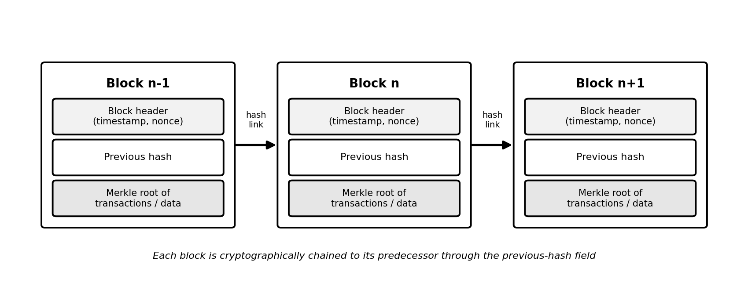
Figure 2.1: Basic structure of a blockchain showing hash-linked blocks
Several architectural components recur across blockchain systems. A cryptographic hash function, such as SHA-256, maps an input of arbitrary size to a fixed-length digest in a way that is practically irreversible and collision-resistant, so that even a one-character change to a record produces an entirely different digest. A Merkle tree organizes the hashes of many records into a single root hash, allowing the integrity of any individual record to be verified efficiently without examining the whole dataset (Alzubi, 2021). A consensus mechanism allows the distributed nodes to agree on the contents and ordering of the ledger; proof-of-work, proof-of-stake and the more lightweight protocols used in permissioned settings represent different points on a spectrum that trades energy and latency against decentralization. Smart contracts, finally, are programs deployed on the ledger that execute automatically when predefined conditions are met, enabling the ledger to enforce rules rather than merely record data (Taherdoost, 2023).
Blockchains are commonly classified by their access model. A public or permissionless blockchain, such as the Ethereum mainnet, allows anyone to join and participate, maximizing decentralization but at the cost of throughput, latency and, frequently, the public visibility of transactions. A private or permissioned blockchain restricts participation to known, vetted nodes, sacrificing some decentralization in exchange for higher throughput, lower latency, finer governance and the confidentiality appropriate to regulated data; the Hyperledger family is the canonical example. A consortium blockchain is a permissioned variant governed jointly by several organizations. The literature on healthcare blockchains converges strongly on permissioned and consortium models, precisely because the open visibility and low throughput of public chains are ill-suited to sensitive, high-volume clinical data (Zaabar et al., 2021; Yaqub et al., 2025). This study adopts a permissioned model for the same reasons.
The choice among these blockchain types has direct practical consequences for a healthcare deployment. A public, permissionless network offers the strongest decentralization but exposes transaction metadata to the world, imposes monetary transaction costs and delivers throughput and latency that are ill-matched to the volume and confidentiality of clinical data. A permissioned network, by contrast, restricts participation to vetted nodes operated by known institutions, which removes the public exposure of metadata, eliminates speculative transaction costs, raises throughput and supports the governance arrangements that regulated healthcare requires, at the acceptable price of reduced decentralization. For these reasons the recent healthcare literature converges strongly on permissioned and consortium models, and platforms compatible with the Ethereum Virtual Machine are attractive because they combine a mature smart-contract environment and tooling with the option of permissioned deployment (Zaabar et al., 2021; Yaqub et al., 2025). The present study accordingly adopts a permissioned Ethereum Virtual Machine network, which provides the expressive smart contracts needed for on-chain access control and integrity anchoring while retaining the confidentiality, performance and governance characteristics that a clinical setting demands.

2.7 Blockchain for Integrity Verification in Electronic Health Records
A naive application of blockchain to health records would attempt to store the records themselves on the chain, but this is widely recognized as impractical because clinical records, particularly imaging studies, are large, because storing them on-chain would be prohibitively expensive and slow, and because permanently and immutably replicating sensitive data across many nodes conflicts with privacy law and with the patient's right to have data corrected or erased. The dominant pattern in the recent literature is therefore the off-chain storage with on-chain anchoring model, in which the encrypted record is stored in a conventional or distributed off-chain store while only its cryptographic hash, together with metadata such as a timestamp and the identity of the author, is committed to the blockchain (Mayer et al., 2020; Kiani et al., 2023). To verify integrity at any later time, the system re-computes the hash of the stored record and compares it with the immutable hash on the chain; any discrepancy proves that the record has been altered.
This pattern delivers the integrity guarantee the study requires while containing the cost and privacy drawbacks of blockchain. It also yields, as a by-product, an immutable and independently verifiable audit trail, because every creation and modification of a record is represented by a corresponding, time-ordered, tamper-evident entry on the chain. Alzubi (2021) demonstrates a related approach in which Merkle-based digital signatures anchor the authenticity of health data generated by connected devices, and Sharma et al. (2023) show how hashing combined with blockchain preserves the privacy and integrity of data in IoT-enabled healthcare. The integrity verification component of the present study builds directly on this off-chain-storage, on-chain-anchoring tradition.
Researchers nonetheless caution that integrity anchoring is not a panacea. The off-chain store remains responsible for confidentiality and availability and must therefore be encrypted and backed up; the binding between the off-chain record and its on-chain hash must be managed carefully so that records cannot be substituted; and the throughput and latency of the chosen chain bound the rate at which records can be committed (Kiani et al., 2023). These considerations directly shape the methodology adopted in Chapter Three, in which encryption, key management and performance measurement are treated as first-class concerns rather than afterthoughts.
Researchers emphasize that the off-chain store retains important responsibilities under this pattern and cannot be neglected. Because the clinical content itself resides off-chain, that store remains responsible for the confidentiality and availability of the data and must therefore be encrypted and reliably backed up, and the binding between an off-chain record and its on-chain anchor must be managed carefully so that records cannot be silently substituted for one another. Kiani et al. (2023) observe further that the throughput and latency of the chosen chain bound the rate at which records can be anchored, which is an additional reason to prefer a permissioned network and to keep the on-chain data minimal. These considerations mean that integrity anchoring is best understood not as a single mechanism but as a discipline spanning the encryption of the store, the management of keys, the careful binding of records to their anchors and the verification procedure itself, and the design in this study treats each of these elements explicitly rather than assuming that the mere presence of a blockchain is sufficient on its own.

2.8 Access Control Models and Role-Based Access Control
Access control is the mechanism by which a system decides whether a given subject may perform a given operation on a given object. The literature distinguishes several classical models. Discretionary access control (DAC) leaves access decisions to the discretion of the resource owner and is flexible but error-prone and difficult to audit at scale. Mandatory access control (MAC) enforces system-wide policies based on security labels and is rigid but strong. Role-based access control (RBAC) assigns permissions to roles and assigns users to roles, so that a user acquires permissions only through role membership, which aligns naturally with the way organizations actually delegate authority. Attribute-based access control (ABAC) generalizes this further by basing decisions on arbitrary attributes of the subject, object and environment, offering the greatest expressiveness at the cost of greater complexity (Yaqub et al., 2025). Table 2.1 summarizes the comparison that recurs across this literature.
Model | Basis of decision | Suitability for EHR
DAC | Owner's discretion over each resource | Flexible but weakly auditable and prone to privilege creep
MAC | System-enforced security labels | Strong but rigid; hard to map onto fluid clinical roles
RBAC | Permissions assigned to organizational roles | Strong fit; clinical authority is naturally role-structured
ABAC | Attributes of subject, object, environment | Highly expressive but complex to administer and verify
Table 2.1: Comparison of major access-control models
Role-based access control is particularly well matched to the healthcare setting because clinical responsibility is inherently organized around roles such as physician, nurse, receptionist and administrator, each of which carries a well-understood and relatively stable set of legitimate permissions. The model also embodies the principle of least privilege, since a user receives only the permissions attached to the role required for his or her duties, and it simplifies administration and auditing, since access can be reasoned about at the level of roles rather than individuals. These advantages explain why RBAC, formalized in the widely adopted standard developed by the United States National Institute of Standards and Technology, remains the dominant access-control model in enterprise and health systems.
The recent literature increasingly couples RBAC with blockchain by encoding role definitions and permission checks within smart contracts. Exceline and Nagarajan (2023) review such schemes and observe that placing the access-control logic on an immutable ledger means that the rules themselves cannot be silently altered and that every access decision is logged. Yaqub et al. (2025) implement a policy-based access-control mechanism on a permissioned blockchain in which smart contracts mediate every request, giving the patient continuous visibility of who holds access rights, while a smart-contract-driven scheme reported by Dutta and Barman (2024) integrates role-based control with integrity checking so that access governance and tamper detection are unified within a single mechanism. This convergence of RBAC and blockchain is the precise design space that the present study occupies.
The role-based access control model, as formalized by the National Institute of Standards and Technology, is defined in terms of a small number of elements whose interaction gives the model its power. Users are assigned to roles, permissions are assigned to roles, and a user acquires permissions only by virtue of the roles to which the user is assigned, while sessions allow a user to activate a subset of assigned roles at a given time. More advanced variants add role hierarchies, in which senior roles inherit the permissions of junior roles, and constraints such as separation of duty, which prevent a single user from holding combinations of roles that would enable abuse. For a healthcare setting these features map naturally onto reality: the roles correspond to recognized clinical and administrative functions, the assignment of permissions to roles mirrors professional scope of practice, and separation of duty corresponds to established controls that prevent oversight from being evaded. The model adopted in this study uses the core elements of users, roles and permissions, which are sufficient for the six clearly distinguished roles identified during analysis.

2.9 Authentication and Identity Management in Health Information Systems
Access control presupposes authentication: a system can only confine a user to the permissions of a role once it has reliably established which user, and therefore which role, is making a request. The literature on health-information systems treats authentication and identity management as a distinct and critical layer of defense, because a large proportion of breaches originate not in the failure of cryptography but in the compromise or misuse of credentials (Keshta & Odeh, 2021). Traditional designs store password hashes within the application's own database, which makes the credential store itself a high-value target and places the burden of secure password handling on every application.
A more modern pattern, and the one adopted in this study, delegates authentication to a dedicated identity provider that issues short-lived, cryptographically signed tokens, commonly in the form of JSON Web Tokens, which the application verifies on each request without ever handling the user's password directly. This separation of the identity concern from the application concern reduces the attack surface, centralizes the enforcement of strong authentication policies and yields a verifiable claim of identity and role that can drive access-control decisions. Recent blockchain-based access-control schemes increasingly assume such token-based authentication as the entry point to an on-chain authorization check, so that the identity established by the provider is then mapped to the role whose permissions the smart contract enforces (Yaqub et al., 2025). The present study follows this layered model, treating authentication, performed by an external identity provider, and authorization, performed by an on-chain role-based mechanism, as separate and complementary stages of every protected operation.

2.10 Review of Related Systems
A number of blockchain-based electronic health record systems have been proposed and, in varying degrees, implemented over the past several years, and a review of the most significant of them clarifies what has been achieved and what remains to be done. Tanwar, Parekh and Evans (2020) designed and evaluated a blockchain-based EHR system for Healthcare 4.0 applications using a permissioned Hyperledger Fabric network, reporting practical throughput while emphasizing access control through chaincode. Mayer, da Costa and Righi (2020) conducted a systematic review of EHR-on-blockchain proposals and concluded that, although the conceptual case was well established, comparatively few proposals had progressed to evaluated implementations, and fewer still addressed the storage problem rigorously. Shi et al. (2020) surveyed the field from the specific standpoint of security and privacy and catalogued the recurring techniques of off-chain storage, encryption and on-chain anchoring.
More recent work has sharpened the focus on access control and integrity together. Zaabar et al. (2021) presented HealthBlock, a secure healthcare data-management system built on a permissioned blockchain with attribute-based access control and off-chain storage, demonstrating both feasibility and acceptable performance. Exceline and Nagarajan (2023) provided a systematic review specifically of the security of blockchain-based electronic health records and identified open challenges around scalability, key management and usability. Yaqub et al. (2025) implemented and evaluated a policy-based access-control mechanism governed by Ethereum smart contracts with explicit attention to regulatory compliance. The systematic reviews of Kiani et al. (2023) and Ettaloui et al. (2024) together synthesise dozens of such systems and confirm both the promise of the approach and the persistence of unresolved engineering challenges. Table 2.2 summarizes a representative selection.
System / study | Core approach | Principal contribution and limitation
Tanwar et al. (2020) | Hyperledger Fabric, chaincode access rules | Working permissioned EHR; limited usability evaluation
Zaabar et al. (2021) | Permissioned chain, ABAC, off-chain store | Strong security model; complex policy administration
Exceline & Nagarajan (2023) | Systematic review of RBAC/ABAC schemes | Maps the field; identifies scalability and usability gaps
Yaqub et al. (2025) | Ethereum smart-contract policy control | Patient-visible access rights; public-chain cost concerns
Table 2.2: Summary of selected related blockchain-based EHR systems
Across these works a consistent picture emerges. The combination of a permissioned blockchain, off-chain encrypted storage, on-chain hash anchoring and smart-contract-enforced access control has become the de facto reference architecture for secure electronic health records, and its security benefits are well evidenced. At the same time, the reviews are unanimous that the literature is dominated by conceptual and laboratory proposals, that usability and human factors are under-studied, and that almost none of the work is situated in or evaluated against the constraints of low-resource healthcare settings such as those of sub-Saharan Africa. These observations directly motivate the design choices and the contextual focus of the present study.
Beyond the systems tabulated above, several further contributions sharpen the picture of the field's trajectory. Sharma et al. (2023) addressed the specific problem of privacy preservation in healthcare enabled by the Internet of Things, combining hashing and blockchain to protect data originating from connected medical devices, and demonstrated that the integrity-anchoring approach generalizes beyond manually entered records to machine-generated data streams. Alzubi (2021) contributed a blockchain-based digital-signature scheme built on Merkle and Lamport constructions, providing an efficient mechanism for authenticating health data and illustrating the role of advanced signature schemes in resource-constrained environments. Taherdoost (2023) offered a critical review of smart contracts themselves, cataloguing both their promise as autonomous, tamper-resistant enforcers of policy and their characteristic risks, including coding vulnerabilities and the difficulty of amending a contract once it has been deployed, considerations that directly informed the cautious and narrowly scoped contract design adopted in this study. Across the systematic reviews of Kiani et al. (2023) and Ettaloui et al. (2024), which between them synthesise several dozen primary studies, a clear maturation is visible: early work concentrated on demonstrating that blockchain could in principle secure health records, whereas more recent work increasingly attends to access control, regulatory compliance, performance and the practicalities of deployment.
What remains comparatively rare, even in this more mature literature, is the combination, within a single implemented and evaluated artefact, of integrity anchoring, fine-grained role-based access control, an immutable audit trail, patient-facing consent management and an explicit usability assessment, evaluated against the constraints of a developing-country context. It is precisely this combination that the present study assembles, and the comparison with prior systems clarifies both how much the design borrows from established practice and where its distinctive contribution lies.

2.11 Challenges and Open Issues in Blockchain-Based EHRs
Although the reference architecture surveyed above is well evidenced, the systematic reviews are equally consistent in identifying a set of challenges that remain only partially resolved, and an honest account of the literature must acknowledge them. The most frequently cited is scalability and performance: public blockchains in particular suffer from limited transaction throughput and non-trivial latency, which is a principal reason the literature, and this study, favor permissioned ledgers and confine the chain to small hash anchors rather than full records (Kiani et al., 2023; Exceline & Nagarajan, 2023). Closely related is the storage problem, since replicating data across many nodes is costly and conflicts with privacy law; the off-chain storage pattern mitigates but does not eliminate the need to secure and back up the off-chain store.
A second cluster of challenges concerns key management, because the security guarantees of any cryptographic system ultimately reduce to the secrecy and availability of keys, and the loss or compromise of a private key can be catastrophic and is difficult to remedy on an immutable ledger (Exceline & Nagarajan, 2023). A third concerns on-chain privacy, since even metadata committed to a ledger can leak information if not carefully minimized. A fourth, and one that the reviews repeatedly observe to be under-studied, concerns usability and human factors: a system that is secure but unusable will not be adopted, and the literature contains comparatively little rigorous evaluation of how clinical users actually experience blockchain-based records (Ettaloui et al., 2024). Finally, the reviews note a shortage of implemented and contextually evaluated artefacts, especially in low-resource settings. The present study is positioned in direct response to this set of open issues, adopting a permissioned ledger and off-chain anchoring to address scalability and storage, treating key management and privacy minimization as explicit design concerns, and incorporating a usability evaluation situated in the local context.

2.12 Electronic Health Records in the African and Cameroonian Context
The adoption of electronic health records in sub-Saharan Africa has lagged behind that of high-income regions, and the reasons for this lag are directly relevant to the security argument of this study. Reviews of EHR and electronic medical record adoption in the region consistently identify a cluster of barriers comprising weak and unreliable infrastructure, including intermittent electricity and limited network connectivity, high procurement and maintenance costs, limited computer literacy and resistance to change among health workers, and significant concerns about the privacy and security of patient data (Akwaowo et al., 2022). Where electronic records have been adopted, they have frequently been concentrated in donor-funded vertical programmes rather than embedded in routine general care, limiting their reach.
Within this regional picture, studies focusing on Cameroon and comparable settings emphasize that successful adoption depends on adapting systems to local clinical practice, terminology and workflow rather than transplanting designs wholesale, and on securing the trust of both staff and patients (Akwaowo et al., 2022). Security and privacy concerns are therefore not a peripheral obstacle but a central one: a record system that cannot credibly guarantee that data will be neither leaked nor tampered with will struggle to earn the institutional and public trust on which adoption depends. A design that makes integrity mathematically verifiable and access strictly role-bounded speaks directly to this trust deficit, which is why the present study situates its contribution explicitly within the Cameroonian context while drawing on the broader international literature for its technical foundations.
Several features of the regional context bear directly on the design choices appropriate to it. The intermittency of electricity and the limited bandwidth reported across the region argue for systems that are lightweight, that tolerate constrained connectivity and that run on ordinary hardware rather than demanding specialized or continuously connected infrastructure. The relatively high cost of procurement and maintenance argues for the use of open and widely available technologies rather than expensive proprietary platforms. The documented importance of user acceptance and trust argues for interfaces that are simple and role-appropriate and for security guarantees that are visible to users rather than hidden, so that staff and patients can see that records are protected. The design pursued in this study responds to each of these features, and in doing so it treats the constraints of the setting not as obstacles to be lamented but as requirements to be designed for, which is consistent with the conclusion of the adoption literature that the systems that succeed are those tailored to local conditions (Akwaowo et al., 2022).

2.13 Theoretical Framework
This study is anchored in three complementary theoretical foundations. The first is the CIA triad of confidentiality, integrity and availability, the classical model of information security against which the design is assessed; the study concentrates on confidentiality and integrity while treating availability as a constraint to be respected. The second is the role-based access control model formalised by the United States National Institute of Standards and Technology, which provides the formal vocabulary of users, roles, permissions and sessions used to specify and reason about the access-control component of the system. The third is the principle of least privilege, the security design principle holding that every subject should operate with the minimum set of privileges necessary to perform its function, which the role-based model operationalises directly.
To interpret the usability and acceptance dimension of the evaluation, the study additionally draws on the Technology Acceptance Model, which holds that the perceived usefulness and perceived ease of use of a technology jointly shape users' intention to adopt it. This model is widely used in health-information-technology research and is appropriate here because the African adoption literature reviewed above identifies user acceptance as a decisive factor. Together these frameworks provide both the engineering criteria against which the security of the artefact is judged and the behavioral lens through which its acceptance by users is interpreted.
These frameworks operate at complementary levels of the study. The confidentiality, integrity and availability triad and the principle of least privilege function as evaluative criteria, supplying the standard against which the security of the artefact is judged and the rationale for assigning encryption to confidentiality, hash anchoring to integrity and role-based restriction to least privilege. The role-based access control model supplies the formal structure of the access-control component, defining the relationships among users, roles, permissions and sessions that the smart-contract implementation realizes. The Technology Acceptance Model, by contrast, operates at the level of human behavior, providing the constructs of perceived usefulness and perceived ease of use through which the study interprets the responses of users and anticipates the likelihood of adoption, an inclusion that reflects the finding from the adoption literature that technical adequacy alone does not secure uptake. Underpinning the work as a whole is the design-science paradigm, which frames the construction and evaluation of an artefact as a legitimate mode of knowledge production and which requires that the artefact be evaluated rigorously against the problem it was built to solve.

2.14 Summary and Research Gap
This chapter has established that electronic health records deliver substantial benefits but only on the condition that their confidentiality and integrity are assured, that conventional centralized systems fail to assure these properties because they concentrate trust and create single points of failure, and that the recent literature has converged on a reference architecture combining a permissioned blockchain, off-chain encrypted storage, on-chain hash anchoring and smart-contract-enforced role-based access control as a credible solution. The review has also shown that this architecture is well evidenced in principle but comparatively under-realized in practice, that usability and human factors remain under-studied, and that almost no work evaluates such systems within the resource-constrained healthcare settings of sub-Saharan Africa.
The research gap that this study addresses is therefore threefold. First, there is a shortage of fully implemented and evaluated artefacts, as opposed to conceptual proposals, that integrate blockchain integrity verification with role-based access control. Second, the usability and user-acceptance of such systems is insufficiently examined. Third, and most pointedly, there is an absence of designs developed for and evaluated against the constraints of a developing-country setting such as Cameroon, where security concerns have themselves been a barrier to digital health adoption. By designing, implementing and evaluating a secure electronic health record prototype that unifies blockchain integrity verification and role-based access control with explicit attention to usability and to the local context, this study contributes directly to closing that gap. The methodology by which this is accomplished is presented in the next chapter.

CHAPTER THREE: METHODOLOGY

3.1 Introduction
This chapter explains how the research was conducted. It answers three guiding questions: how requirements were gathered, how the system was designed and how it will be analyzed and evaluated, and what processes, methods, techniques and tools were used to accomplish the work. The chapter first sets out the overall research design, then describes the requirements-gathering methods and the population and sample, then presents the system-development methodology together with the analysis-and-design tools and the development technologies, and finally describes the quantitative analysis, the evaluation metrics, the testing strategy and the ethical considerations that govern the study.

3.2 Research Design
The study adopts an applied, problem-solving research design of the kind appropriate to an engineering project, combining a software-development component with a quantitative evaluation component. Specifically, it follows the design-science paradigm, in which knowledge is generated through the construction and rigorous evaluation of a purposeful artefact, in this case a secure electronic health record system. This design is appropriate because the research questions are not concerned with the effect of one variable on another but with whether and how well a designed artefact can detect tampering and enforce role-based access, which are questions answered by building and testing the artefact rather than by observation alone. In keeping with the guidance that the strongest applied research couples an engineering component with a quantitative component, the construction of the artefact is paired with the quantitative measurement of its performance and of users' perceptions of it.
The adoption of the design-science paradigm carries with it a commitment to methodological rigor in both the construction and the evaluation of the artefact. In the construction, rigor is pursued by grounding each design decision in the gathered requirements and in the established literature reviewed in Chapter Two, so that the artefact embodies known good practice rather than ad hoc invention. In the evaluation, rigor is pursued by assessing the artefact against criteria that are defined in advance and that follow directly from the problem, namely the detection of tampering, the prevention of unauthorized access, measurable performance and the perceptions of intended users, and by combining objective, experiment-based measurement with subjective, questionnaire-based assessment so that the artefact is examined from more than one vantage point. This dual evaluation, pairing an engineering demonstration with a quantitative measurement of behavior and perception, is what distinguishes a disciplined design-science study from a mere prototype demonstration, and it is the reason the methodology that follows treats data gathering, design, implementation and evaluation as an integrated whole rather than as isolated activities.

3.3 Requirements Gathering
Requirements for the system were gathered through a combination of four complementary methods chosen to triangulate the needs of the intended users and the constraints of the setting. Document review was used to establish the functional and regulatory baseline: existing course materials and standard texts on electronic health records, on the privacy, confidentiality and security framework, on EHR implementation and on the administrative use of the record were analyzed to extract the data elements, workflows and safeguards that a credible system must support, and the peer-reviewed literature reviewed in Chapter Two supplied the security requirements. Semi-structured interviews with a small number of healthcare staff were used to understand real clinical and administrative workflows, the roles that exist in practice and the points at which records are created, read and modified.
Questionnaires, administered both physically and through an online form, were used to gather data at greater scale on current record-keeping practices, on perceived security weaknesses and on expectations of a new system, yielding the quantitative baseline against which the evaluation is later compared. Direct observation of record-handling in a medical-office setting, supported by the simulated workflows of medical-office practice software, was used to corroborate the interview and questionnaire data and to surface tacit practices that respondents might not articulate. Taken together, these methods produced a requirements specification expressing the functional requirements, such as patient registration and encounter documentation, and the non-functional requirements, foremost among them integrity verification, role-based confidentiality and auditability.
Each gathering method was chosen to compensate for the weaknesses of the others. Document review established an authoritative baseline but could not reveal how procedures are actually performed; interviews surfaced real practice and the reasoning behind it but reached only a small number of informants; questionnaires reached more respondents and yielded quantifiable data but constrained the depth of response; and observation captured tacit behavior that respondents might not articulate but could not, on its own, explain motivation. By triangulating across these four sources, the study sought requirements that were at once authoritative, grounded in practice, quantifiable and behaviorally realistic. The instruments themselves were designed with care: interview guides were kept semi-structured so that informants could raise concerns the researcher had not anticipated, and questionnaire items were framed in plain language and, where they concerned perception, anchored on a consistent response scale so that the resulting data could be summarized and, after implementation, compared against the post-use assessment described later in this chapter.

3.4 Population and Sample
The target population for the requirements-gathering and evaluation activities comprises the staff of a medical facility whose duties involve the creation, retrieval or administration of patient records, together with a sample of patients as record subjects. Because the population is organized around well-defined occupational roles and because the study requires informed input from each role rather than a statistically representative cross-section of a large homogeneous population, a purposive (non-probability) sampling technique was adopted, supplemented by convenience sampling where access constraints required it. This approach ensures that every role relevant to the access-control design is represented in the data. The planned distribution of the sample across roles is presented in Table 3.1; the indicated sizes are targets that balance representativeness against the access and time constraints described among the study's limitations. In the event, the online questionnaire, which was open to patients and members of the public, drew forty-eight responses, exceeding the planned minimum, and the analysis of those responses is reported in Chapter Four.
Respondent category | Sampling basis | Target sample size
Doctors | Purposive | 4
Nurses | Purposive | 5
Laboratory technicians | Purposive | 2
Receptionists / records staff | Purposive | 3
System administrators / IT | Purposive | 2
Patients | Convenience | 14
Total |  | 30
Table 3.1: Target population and sample distribution

3.5 System Development Methodology
The system was developed using an iterative and incremental software-development methodology with prototyping, in preference to the linear waterfall model. This choice is justified on two grounds. First, the security requirements of the system, and particularly the integration of the blockchain integrity layer with the access-control layer, carry technical risk that is best retired early through working prototypes rather than deferred to a single late integration phase. Second, the iterative model accommodates the refinement of requirements that the requirements-gathering activities, especially the user feedback, are expected to produce. Each increment passes through the phases of requirements refinement, analysis, design, implementation and testing, and the evaluation feedback from each increment informs the next, as depicted in Figure 3.1.
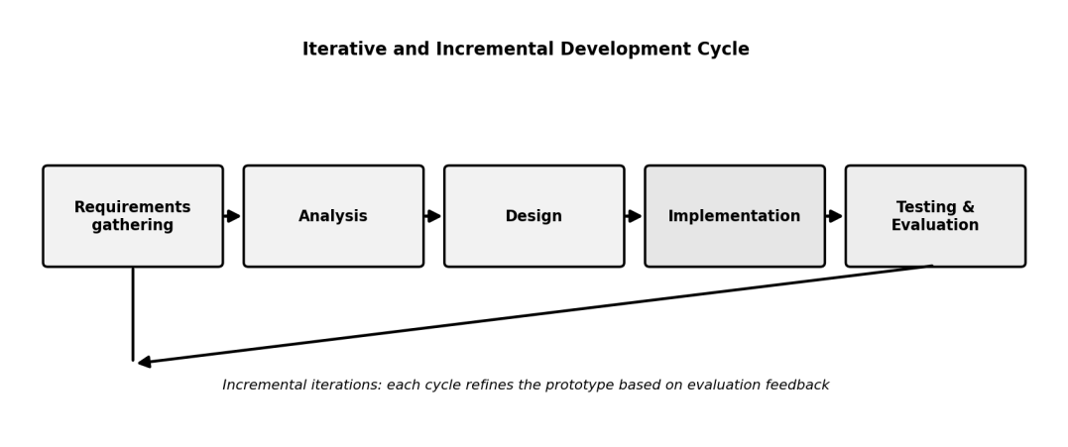
Figure 3.1: Iterative and incremental development methodology adopted for the study
The first increment establishes the core record-management functions and the off-chain encrypted data store. The second increment introduces the blockchain integrity layer, implementing the hashing of records and the anchoring of those hashes on the ledger together with on-demand verification. The third increment implements the role-based access-control engine and the smart-contract-mediated permission checks, and the final increment integrates the components, hardens the system and conducts the full evaluation. This staging ensures that a working, testable artefact exists at every stage and that the highest-risk integration work is undertaken with the lower-risk foundations already proven.
The decision to proceed in increments rather than in a single pass was also a deliberate strategy for managing risk. The integration of an on-chain access-control and integrity layer with a conventional web and database application was the element of the project carrying the greatest technical uncertainty, and an incremental approach allowed this uncertainty to be confronted early, in a working prototype, rather than being deferred to a single late phase in which a failure would have threatened the whole project. Each increment produced an artefact that could be examined and tested, so that defects and misunderstandings were surfaced and corrected while they were still inexpensive to address, and the feedback obtained from each increment refined both the requirements and the design of the next. This staged reduction of risk, rather than adherence to any particular branded process, is the substantive reason an iterative and incremental approach was preferred over a linear one for a project of this character.

3.6 System Analysis and Design Tools
The analysis and design of the system are expressed using the Unified Modeling Language (UML), the de facto standard for object-oriented system modeling, supplemented by entity-relationship modeling for the data layer. Specifically, the study will produce use-case diagrams to capture the interactions of each role with the system, class diagrams to express the static structure of the software, sequence diagrams to model the dynamic flow of key operations such as record creation with hash anchoring and access request with permission checking, and an entity-relationship diagram to model the off-chain data store. The overall layered architecture that these models elaborate is shown in Figure 3.2, comprising a presentation layer, an application and access-control layer, an off-chain encrypted data store, a blockchain integrity layer and the underlying infrastructure.
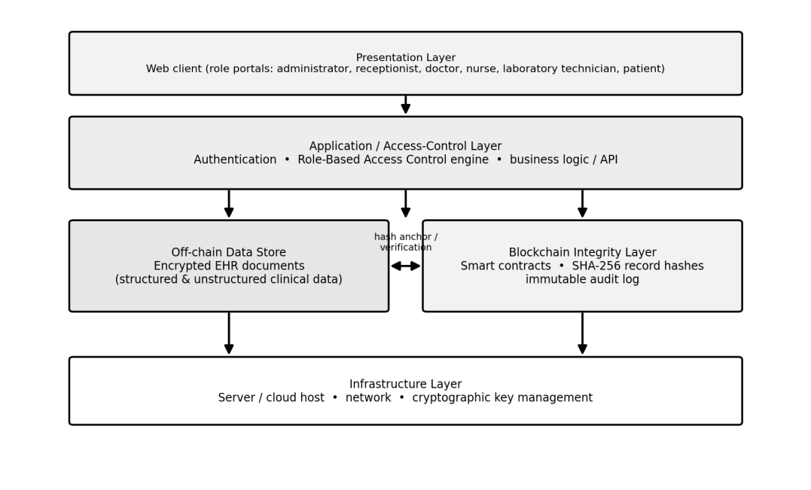
Figure 3.2: High-level architecture of the proposed secure EHR system
The architecture deliberately separates the concern of confidentiality, handled by encryption and role-based access control in the upper layers and the off-chain store, from the concern of integrity, handled by hashing and ledger anchoring in the blockchain layer, so that each property can be reasoned about and tested independently before they are evaluated together. The arrows between the off-chain store and the blockchain layer represent the anchoring of record hashes and their later use in verification, which is the mechanism by which any tampering with the off-chain data is detected.

3.7 Development Tools, Technologies and Techniques
The prototype is implemented as a web application so that it is accessible from ordinary office hardware without specialized client software, a consideration of particular importance in the resource-constrained target setting. The presentation layer is built with standard web technologies and a contemporary component library; the application layer, which houses the business logic and the role-based access-control engine, exposes a programming interface to the client; and the off-chain store holds the encrypted clinical records. Record integrity is provided by computing the SHA-256 hash of each record and committing that hash, with metadata, to a permissioned blockchain through smart contracts, in line with the off-chain-storage, on-chain-anchoring pattern established in the literature. A local blockchain development environment is used so that the integrity and access-control logic can be developed and tested without the cost and latency of a public network. Table 3.2 sets out the roles and their permissions, and Table 3.3 lists the development tools and technologies.
Role | Representative permissions
System administrator | Manage user accounts and role assignments; view audit log; no clinical-content editing
Doctor | Create and read clinical encounter records; order and view investigations; prescribe medication; verify record integrity
Laboratory technician | View assigned laboratory orders; enter and upload verified results; verify record integrity
Nurse | Record and read vitals and nursing notes; read relevant clinical records
Receptionist / records staff | Register patients; manage demographics and appointments; no access to clinical notes
Patient | View own record and audit of who accessed it; grant or revoke consent
Table 3.2: Roles and access permissions in the proposed system
Category | Tools / technologies
Front-end | HTML, CSS and JavaScript with a component framework
Back-end / application logic | A server-side runtime exposing a REST application programming interface
Off-chain data store | A relational or document database with field-level encryption
Blockchain layer | A permissioned ledger with smart contracts; local development network
Cryptography | SHA-256 hashing; standard symmetric encryption for stored records
Modeling and version control | UML modeling tools; Git for version control
Testing | Unit-testing framework; manual functional and security test scripts
Table 3.3: Development tools and technologies
The selection of tools and techniques was governed throughout by the twin constraints of the security requirements and the resource-limited target setting. A web-based delivery was preferred over a native application so that the system could be reached from ordinary office computers through a standard browser without the installation of specialized software, lowering both cost and the barrier to adoption. Established rather than experimental cryptographic primitives were chosen, namely a standardized 256-bit hash and a standardized symmetric cipher, on the principle that a security system should rest on well-understood and widely scrutinised foundations rather than on novel constructions. A permissioned blockchain with a local development network was selected so that the integrity and access-control logic could be built and exercised without incurring the cost, latency or public exposure of a live public network. Version control was used throughout to preserve a complete history of the implementation, and the modeling of the system in the Unified Modeling Language preceded coding so that the structure and behavior of the system were reasoned about before they were committed to code. These choices collectively favored reliability, transparency and transferability over novelty for its own sake.

3.8 Quantitative Analysis and Evaluation Metrics
In keeping with the requirement that applied research embed a quantitative component, the study evaluates the artefact along two quantitative dimensions. The first is technical performance and effectiveness, measured through controlled experiments on the prototype. The second is user perception, measured through a structured post-use questionnaire administered to participants drawn from the sample and analyzed using descriptive statistics such as means, frequencies and percentages, with the items grounded in the perceived-usefulness and perceived-ease-of-use constructs of the Technology Acceptance Model. The questionnaire baseline gathered during requirements gathering provides a point of comparison for the post-use results. The principal metrics are summarized in Table 3.4.
Metric | Definition and purpose
Tamper-detection rate | Proportion of deliberately altered records correctly flagged by integrity verification
Unauthorized-access prevention rate | Proportion of role-violating access attempts correctly denied
Hash-verification time | Mean time to verify the integrity of a record
Transaction-commit latency | Mean time to anchor a record hash on the ledger
Usability score | Mean of perceived-usefulness and ease-of-use questionnaire items
Table 3.4: Evaluation metrics for the prototype
For the tamper-detection and access-prevention metrics, a set of test cases is constructed in which records are deliberately modified at the storage layer and in which access is attempted in violation of the role policy; the system is judged effective to the extent that it flags every tampered record and denies every illegitimate request. The timing metrics are obtained by repeated measurement under controlled conditions and reported as means with dispersion. These quantitative results, presented in Chapter Four, provide objective evidence with which to answer the third research question, while the usability results address the fourth.

3.9 Testing Strategy
Testing proceeds at several levels. Unit testing verifies the correctness of individual components, including the hashing routine, the verification routine and the permission-checking logic. Integration testing verifies that the application layer, the off-chain store and the blockchain layer interoperate correctly, particularly that a record committed through the application is correctly hashed, anchored and later verified. Functional testing confirms that each role can perform exactly its permitted operations and no others, exercising the use cases defined during design. Security testing specifically exercises the tamper-detection and unauthorized-access scenarios described above. This layered strategy ensures that defects are caught at the earliest and cheapest level and that the security properties central to the study are tested directly rather than merely assumed.

3.10 Ethical Considerations
Because the study engages human participants and concerns sensitive health information, it observes several ethical commitments. Participation in interviews and questionnaires is voluntary and based on informed consent, with participants free to withdraw at any point. No real, identifiable patient records are used in development or testing; all clinical data employed are synthetic or fully anonymized, consistent with the principle of anonymity discussed in Chapter Two. Data gathered from participants are stored securely, used only for the purposes of the study and reported only in aggregate so that no individual can be identified. These commitments ensure that the study upholds in its own conduct the very privacy and confidentiality principles that its artefact is designed to protect.
These ethical commitments extended into the technical conduct of the work. Because the system is itself a mechanism for protecting sensitive data, it would have been inconsistent to develop it using real patient information, and so all clinical data used in development, testing and demonstration were synthetic or fully anonymized, with any names and identifiers being fictitious. Data gathered from participants in the requirements and evaluation activities were stored securely, were used solely for the purposes of the study and were reported only in aggregate, so that no individual participant could be identified from the results. In this way the study was careful to uphold, in its own conduct, the very principles of confidentiality, anonymity and accountability that its artefact was designed to enforce, ensuring that the research did not create the kinds of risk it set out to mitigate.

3.11 Summary
This chapter has set out an applied, design-science research methodology in which a secure electronic health record system is constructed and quantitatively evaluated. It has described the four requirements-gathering methods of document review, interviews, questionnaires and observation; the purposive sampling of a role-structured population; the iterative and incremental development methodology with prototyping; the UML and entity-relationship analysis and design tools; the web and permissioned-blockchain implementation technologies; and the performance, security and usability metrics, the multi-level testing strategy and the ethical safeguards that govern the study. The execution of this methodology, comprising the analysis of the gathered requirements, the detailed design, the implementation and the findings of the evaluation, is presented in Chapter Four.

CHAPTER FOUR: ANALYSIS, DESIGN, IMPLEMENTATION AND FINDINGS

4.1 Introduction
This chapter presents the execution of the methodology set out in Chapter Three. It reports the analysis of the requirements that were gathered, the design of the system expressed through architectural and Unified Modeling Language models, the implementation of the working prototype named VitaSecure, the testing carried out on that prototype, and the findings that emerged from the evaluation. In keeping with the structure of an applied dissertation, this chapter reports these results without drawing conclusions or offering interpretation; the conclusions, discussion and recommendations that arise from the findings reported here are reserved for Chapter Five.

4.2 Analysis of Gathered Requirements
The requirements gathered through document review, interviews, questionnaires and observation were analyzed and consolidated into a set of functional and non-functional requirements. The functional requirements were organized by the organizational role that performs them, because the role is the unit on which the access-control design operates, while the non-functional requirements expressed the system-wide qualities, foremost among them confidentiality, integrity and auditability, that the system was required to exhibit irrespective of role.

4.2.1 Findings from the User Survey
A structured questionnaire was administered to patients and members of the public as part of the requirements-gathering exercise, and it received forty-eight responses. The results reported in this subsection are descriptive, and they were used to ground and prioritize the requirements that follow. The responses first confirmed that the problem the study addresses is felt by users. When asked how satisfied they were with the way their medical records are currently managed, on a scale from one to five, a majority of respondents chose the lower or middle points of the scale, with only about a fifth selecting the two highest levels of satisfaction, as shown in Figure 4.1.
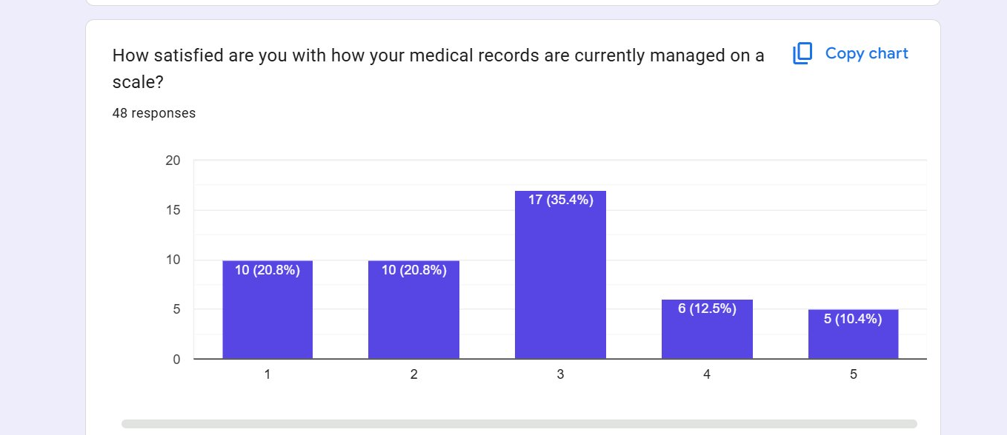
Figure 4.1: Respondent satisfaction with current medical-records management
Consistent with the uneven state of digitisation in the setting, respondents were almost evenly divided, with a substantial proportion unsure, when asked whether their medical records had ever been kept electronically by a hospital, as shown in Figure 4.2, indicating that electronic record-keeping is neither universal nor uniformly visible to patients.
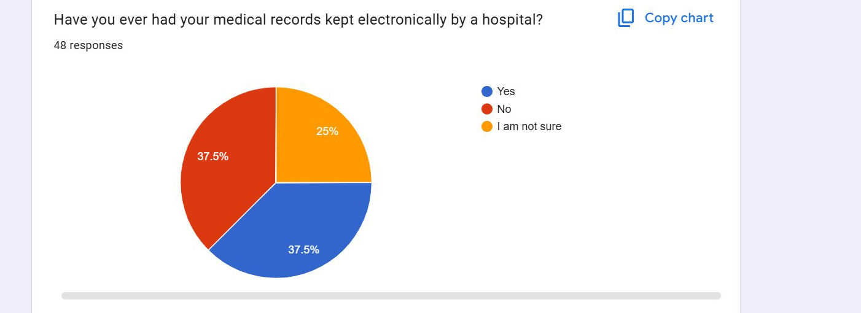
Figure 4.2: Respondents whose records had been kept electronically
Concerns about the confidentiality of records were also evident. While just over half of respondents had not felt that their medical information had been shared without their permission, a combined minority either had felt so or were unsure, as shown in Figure 4.3, which points to a real, if not universal, anxiety about unauthorized disclosure.
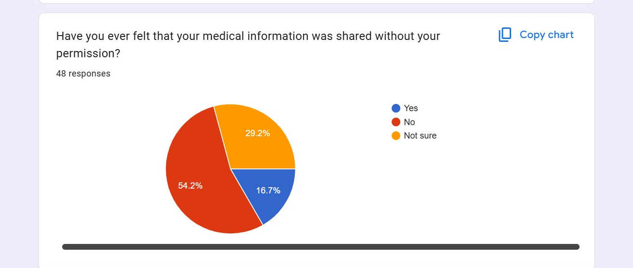
Figure 4.3: Respondents who felt their information had been shared without permission
The survey then established the value that users place on security. A clear majority rated the importance of keeping their medical records private and secure at the highest point of a five-point scale, with more than two-thirds choosing one of the two highest points, as shown in Figure 4.4.
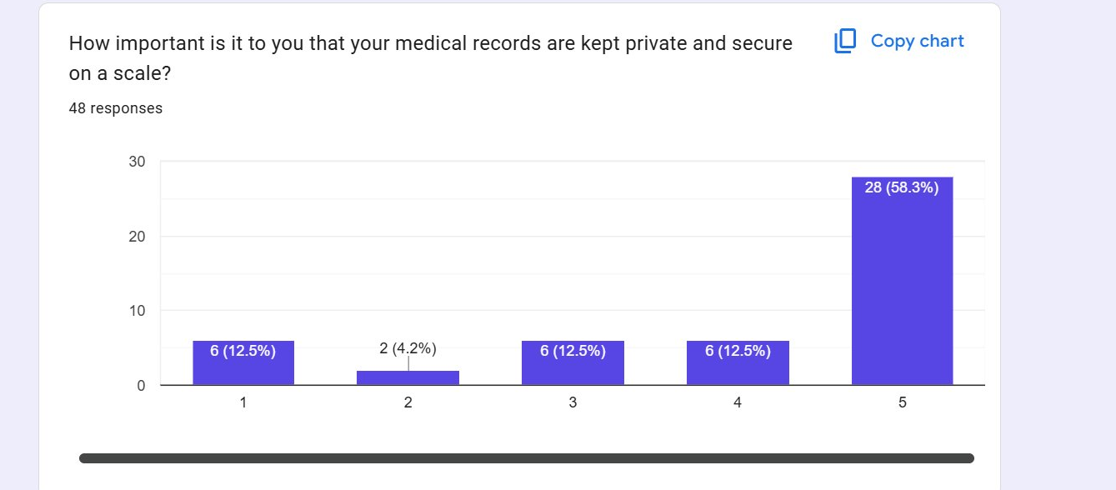
Figure 4.4: Importance respondents place on records being kept private and secure
This concern translated directly into support for encryption. When asked whether they would feel safer knowing that their records were encrypted so that no one could read them without authorization, almost all respondents answered that they would, as shown in Figure 4.5. This near-unanimous result provided strong justification for the requirement that records be encrypted at rest.
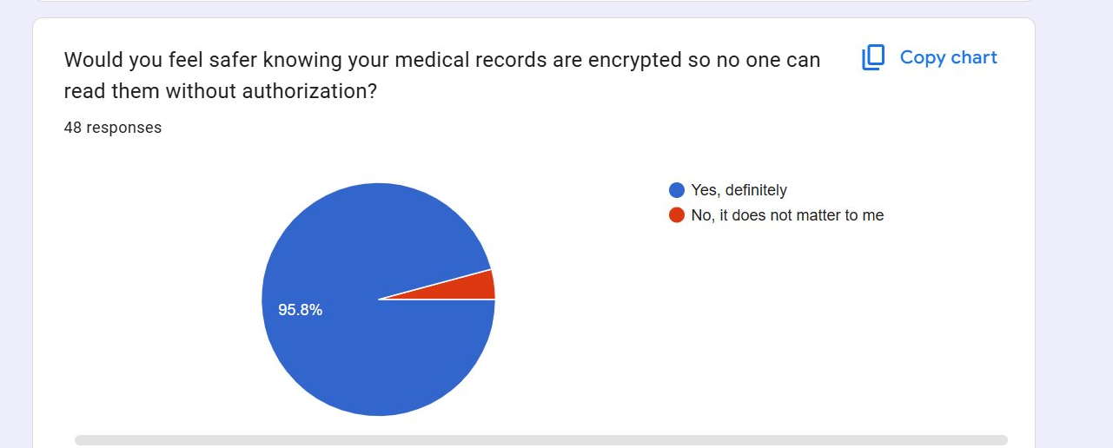
Figure 4.5: Respondents who would feel safer with encrypted records
On the question of who should control access to records, a large majority felt that the patient should have at least some control over which doctor or specialist may view their records, whether full control or control shared with the facility, as shown in Figure 4.6, supporting the inclusion of patient-managed consent alongside role-based access control.
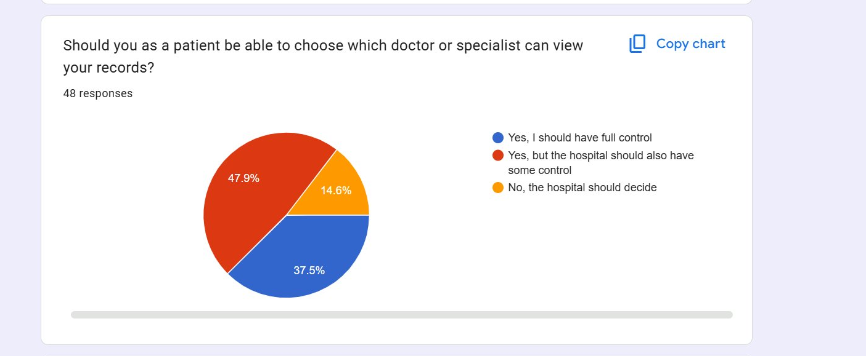
Figure 4.6: Respondent views on patient control over record access
Respondents also expressed a strong desire for transparency of access. A clear majority wished to be notified whenever someone viewed their records, and most of the remainder wished to be notified at least for sensitive records, as shown in Figure 4.7. This finding supported the requirement for an accessible, patient-facing access log.
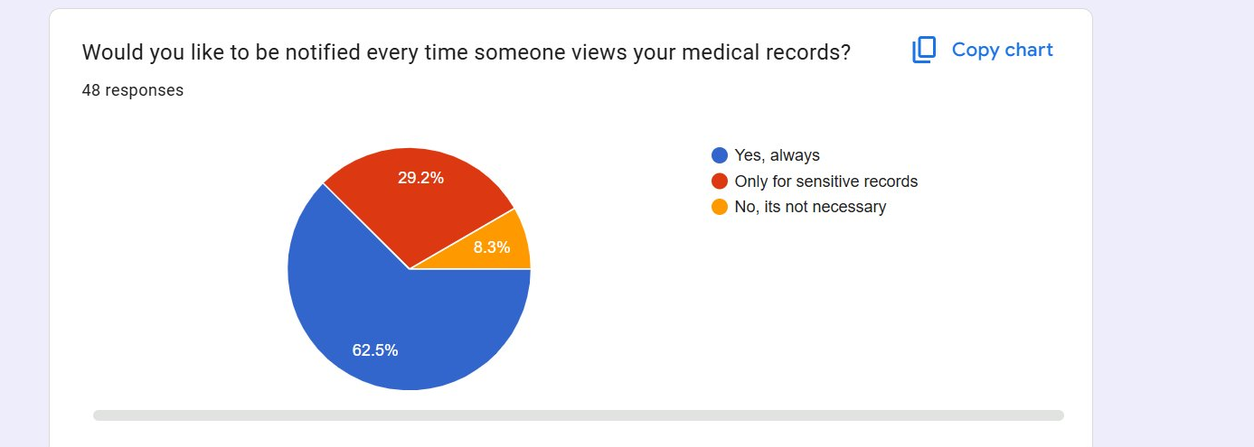
Figure 4.7: Respondent preferences for notification when records are viewed
Two questions explored the tension between confidentiality and the needs of emergency care. When asked what information they would be comfortable with doctors accessing without their permission while unconscious in an emergency, the largest group was willing to permit access to their full medical history, while others would limit such access to specific elements such as past diagnoses, current medications or blood type, as shown in Figure 4.8, indicating broad but not unconditional acceptance of emergency access.
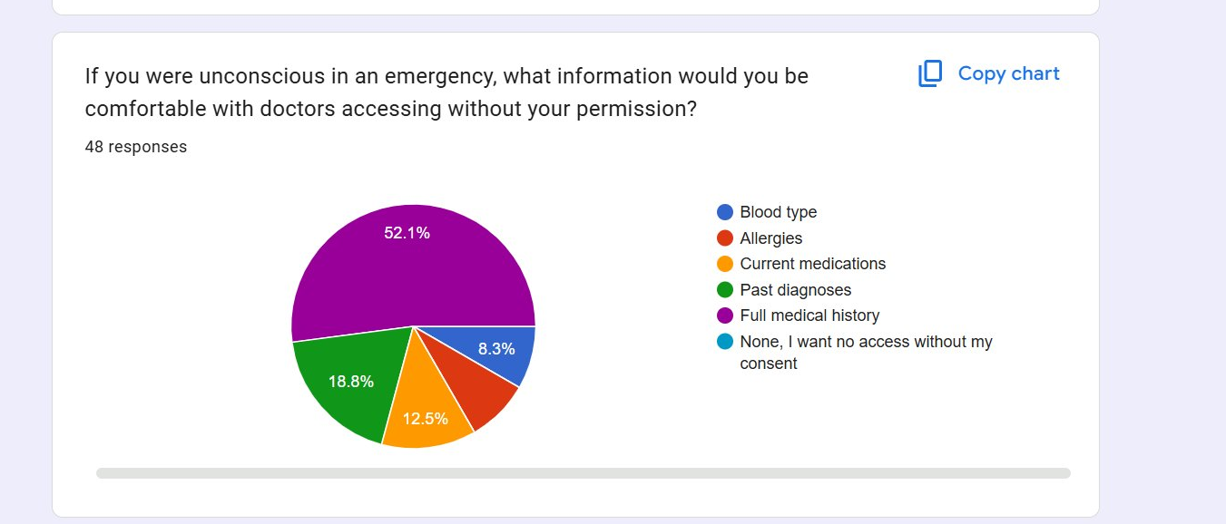
Figure 4.8: Information respondents would permit doctors to access in an emergency
Opinion was more divided on whether emergency access to full records should be automatically withdrawn after a few hours, with a slight majority preferring that access continue until recovery and a substantial minority favoring time-limited access, as shown in Figure 4.9. The design accommodated both preferences by making emergency access explicit, logged and revocable rather than permanent.
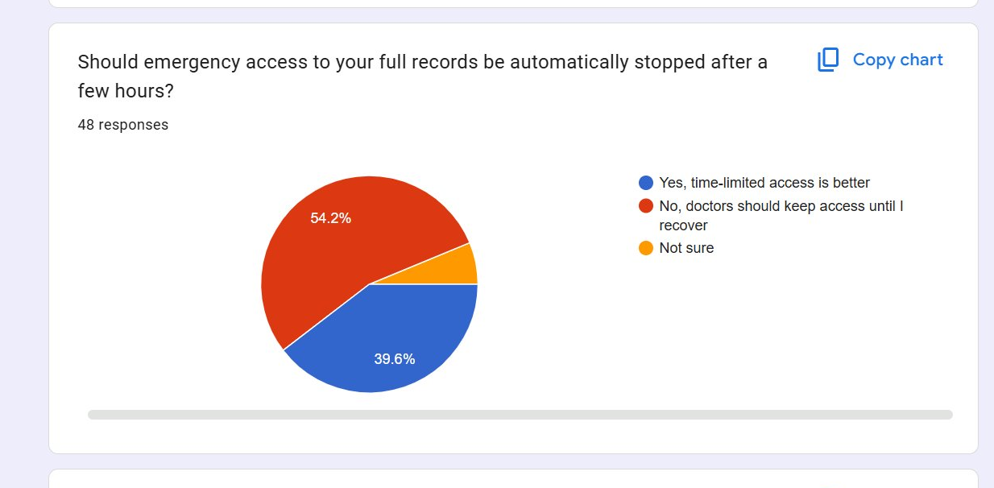
Figure 4.9: Respondent views on time-limited emergency access
Finally, when asked which features they would most want in an electronic health record system, respondents prioritized strong encryption, followed by role-based access control and patient consent management, with emergency access also attracting support, as shown in Figure 4.10. This ordering of user priorities corresponds closely to the security features that the present study set out to provide, and it directly informed the prioritization of the requirements described in the subsections that follow.
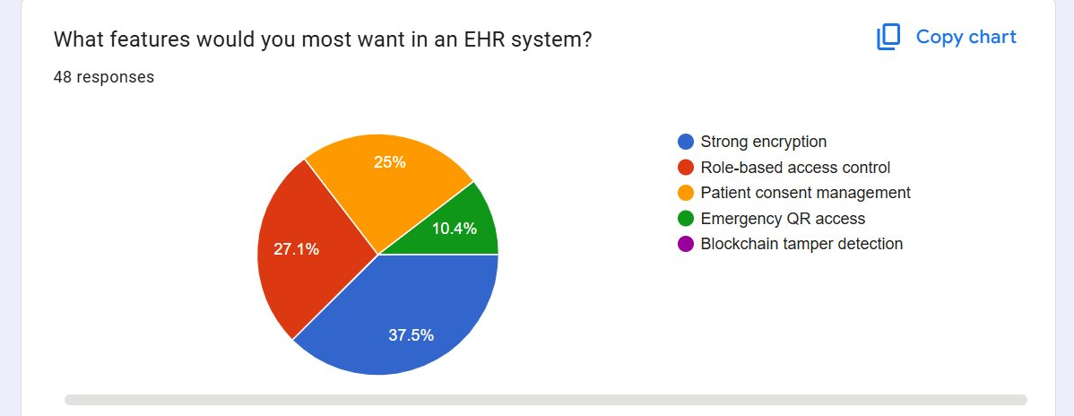
Figure 4.10: Features respondents would most want in an EHR system

4.2.2 Functional Requirements
The analysis confirmed six distinct roles, namely system administrator, receptionist, doctor, nurse, laboratory technician and patient, and established the operations that each role legitimately performs. These role-scoped functional requirements are presented in Table 4.1.
Role | Key functional requirements
System Administrator | Manage user accounts and role assignments; view the audit log and integrity reports; monitor system health; no access to clinical content
Receptionist | Register patients and manage demographic records; schedule and manage appointments; check patients in at the front desk
Doctor | Create and view clinical encounters; order laboratory tests; prescribe medication; view laboratory results; verify record integrity
Nurse | Record and view vitals and nursing notes; view relevant clinical records; consult a read-only medication reference
Laboratory Technician | View assigned laboratory orders; enter and upload verified results; verify record integrity
Patient | View own health record; grant or revoke consent; view the log of who accessed the record; verify record integrity
Table 4.1: Functional requirements by role

4.2.3 Non-Functional Requirements
The non-functional requirements captured the security and quality attributes that the system was required to satisfy across all roles. Confidentiality and integrity were identified during analysis as the two highest-priority attributes, which is consistent with the security literature reviewed in Chapter Two. The principal non-functional requirements are summarized in Table 4.2.
Requirement | Description
Confidentiality | Clinical records are encrypted at rest and access is restricted to the operations permitted to the user's role
Integrity | Every clinical record is hashed and anchored so that any later alteration is detectable on demand
Authentication | Every session is authenticated before any record operation is permitted
Auditability | Every access and every change is recorded in an immutable, time-ordered audit trail
Usability | Each role is presented with a focused dashboard that exposes only its permitted actions
Performance | The system responds promptly under normal load, with large records held off-chain to contain latency and cost
Portability | The system is web-based and runs on ordinary office hardware and standard browsers
Table 4.2: Non-functional requirements of the system
The analysis also clarified the relationships among the requirements. The functional requirements were found to partition cleanly along role boundaries, with very little overlap in the operations that different roles legitimately perform, which confirmed that a role-based rather than a more complex attribute-based model would be sufficient and appropriate for the access-control design. The non-functional requirements, by contrast, were found to cut across all roles and all functions, so that confidentiality, integrity, authentication and auditability had to be guaranteed uniformly regardless of which role was acting or which record was concerned. This distinction shaped the architecture directly: role-specific behavior was localised in the access-control layer and the role-specific interfaces, while the cross-cutting security guarantees were concentrated in the server-side functions and the blockchain layer, where they could be enforced uniformly and could not be circumvented by the choice of interface. The analysis thus translated a list of requirements into an architectural principle, namely that what varies by role should be separated from what must hold for every role, and it is this principle that the design described in the following sections embodies.

4.3 System Design
The design translated the requirements into a concrete, layered architecture and a set of Unified Modeling Language models. The high-level architecture follows the layered structure presented in Figure 3.2 and was realized with a frontend built in vanilla HyperText Markup Language, Cascading Style Sheets and JavaScript; authentication handled by Supabase Auth; an application and data layer provided by Supabase, comprising a managed PostgreSQL database and serverless Edge Functions; and a permissioned Ethereum Virtual Machine blockchain hosting the smart contracts that provide authoritative access control, integrity anchoring and audit logging. A deliberate design decision, visible throughout the models that follow, confined all cryptographic and blockchain responsibilities to the Edge Functions, so that the browser never handles keys, hashes or ledger transactions directly.

4.3.1 Use Case Design
The use case model identifies the six human roles as primary actors and Supabase Auth and the permissioned blockchain as secondary actors that participate in the realization of the use cases. The model captures the cross-cutting behaviors of the system through include relationships: every protected use case includes Authenticate, which is realized through Supabase Auth, and every use case that creates or updates a record includes Anchor Record Hash, which is realized through the blockchain. The complete use case diagram is presented in Figure 4.11.
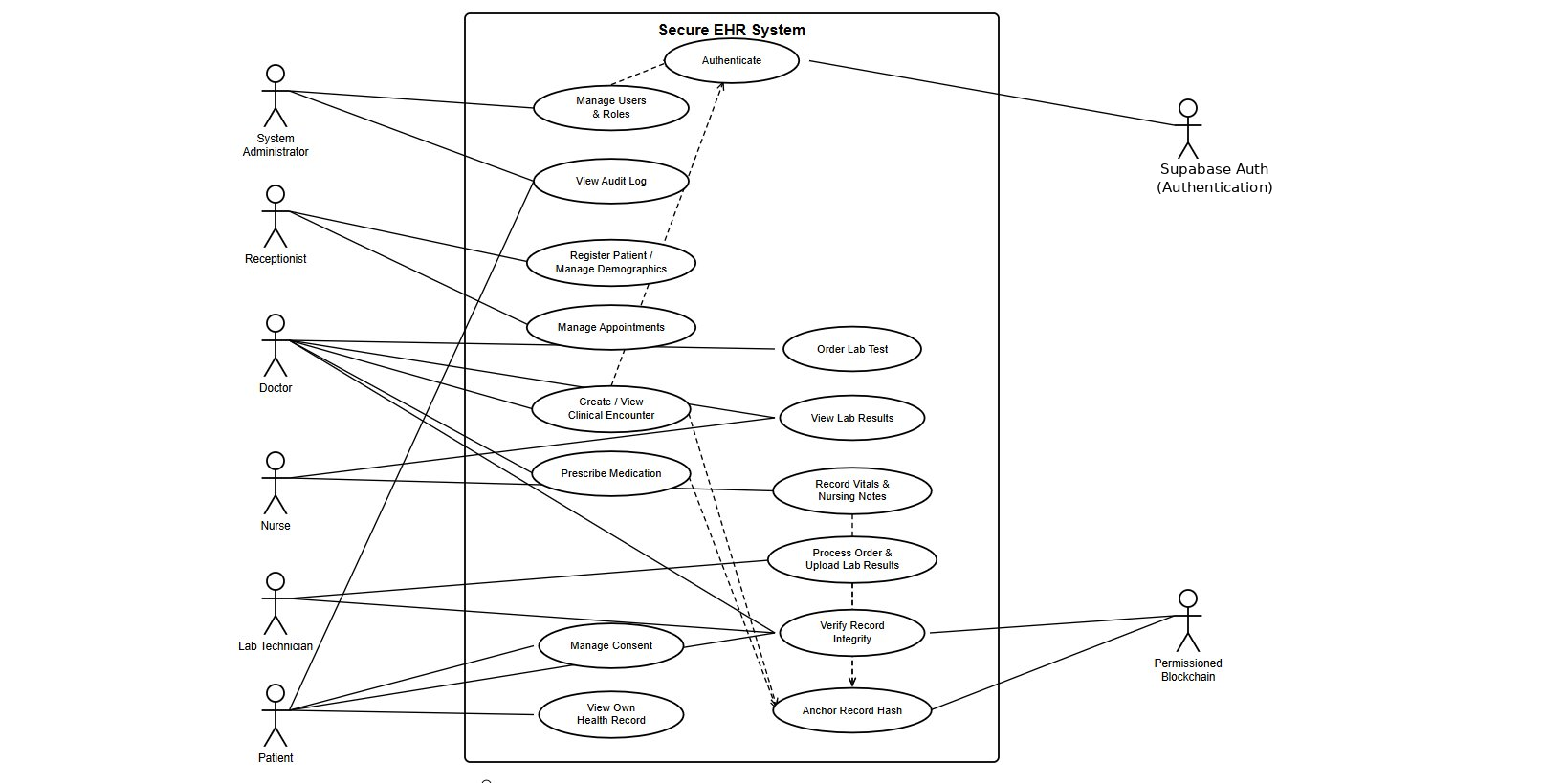
Figure 4.11: Use case diagram of the Secure EHR System (VitaSecure)
The diagram shows, for example, that the doctor reaches the use cases for creating and viewing clinical encounters, ordering laboratory tests, prescribing medication and verifying record integrity, while the patient reaches only the use cases for viewing the own record, managing consent and viewing the audit log. The system administrator is deliberately connected to the management and oversight use cases and not to any use case that exposes clinical content, reflecting the principle of least privilege adopted in the design.

4.3.2 Component Design
The component model decomposes the system into four deployable components together with the external Supabase Auth service, and specifies the interfaces between them. The frontend component communicates with Supabase Auth through its authentication interface and with the Edge Functions through a representational state transfer interface over HyperText Transfer Protocol Secure. The Edge Functions component, which contains the record, integrity and access-control services together with the cryptography, chain and audit modules, communicates with the data store through structured query language and with the smart contracts through remote procedure calls. This decomposition, shown in Figure 4.12, makes explicit that only the Edge Functions component bears the blockchain and cryptographic responsibilities, isolating the most security-sensitive logic in a single, server-side component.
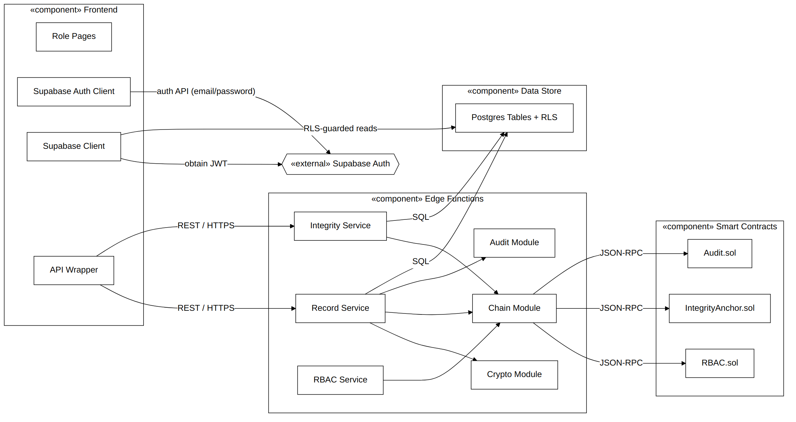
Figure 4.12: Component diagram of the Secure EHR System

4.3.3 Domain Model and Class Design
The domain model expresses the static structure of the system. Its central design feature is the abstract class VerifiableRecord, which carries the version number, the record hash and the on-chain anchor reference, together with the behavior to compute a hash and to verify integrity. The clinical record types, namely Encounter, Vitals, LabResult and Prescription, inherit from VerifiableRecord, so that integrity is a single, shared and reusable property of every clinical record rather than logic repeated in each class. Each verifiable record is anchored by exactly one IntegrityAnchor, and the Role enumeration enumerates the six roles that the access-control model recognizes. The full class diagram is presented in Figure 4.13.
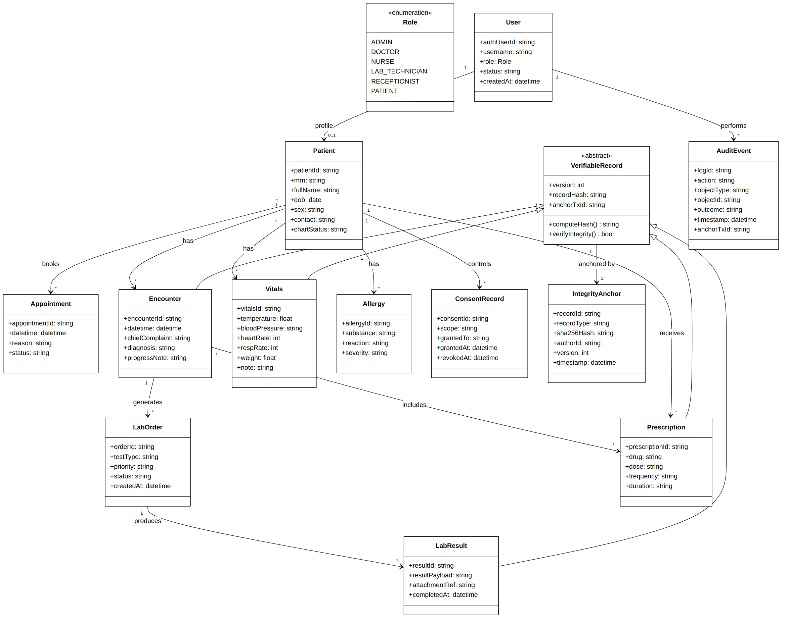
Figure 4.13: Class diagram (domain model) of the Secure EHR System
The model also expresses the principal associations of the domain: a User optionally corresponds to a Patient profile and performs many AuditEvents; a Patient has many Encounters, Appointments, Vitals, Allergies and Prescriptions and controls many ConsentRecords; an Encounter generates LabOrders and includes Prescriptions; and a LabOrder produces a LabResult. These associations directly informed the database schema described in Section 4.3.5.

4.3.4 Process Design (Sequence Diagrams)
The dynamic behavior of the system was modeled through sequence diagrams covering the principal flows. The first, shown in Figure 4.14, models the core write pipeline in which a doctor creates a clinical encounter. The flow authenticates the session through Supabase Auth, verifies the issued token within the Edge Function using the project's secret, authorizes the operation on-chain through the access-control contract, and, on a permitted request, canonicalizes and encrypts the record, stores the ciphertext, computes its hash, anchors that hash on the blockchain and writes an audit event. The alternative fragment shows that a denied request results in an audit event and a refusal, never in a stored record.
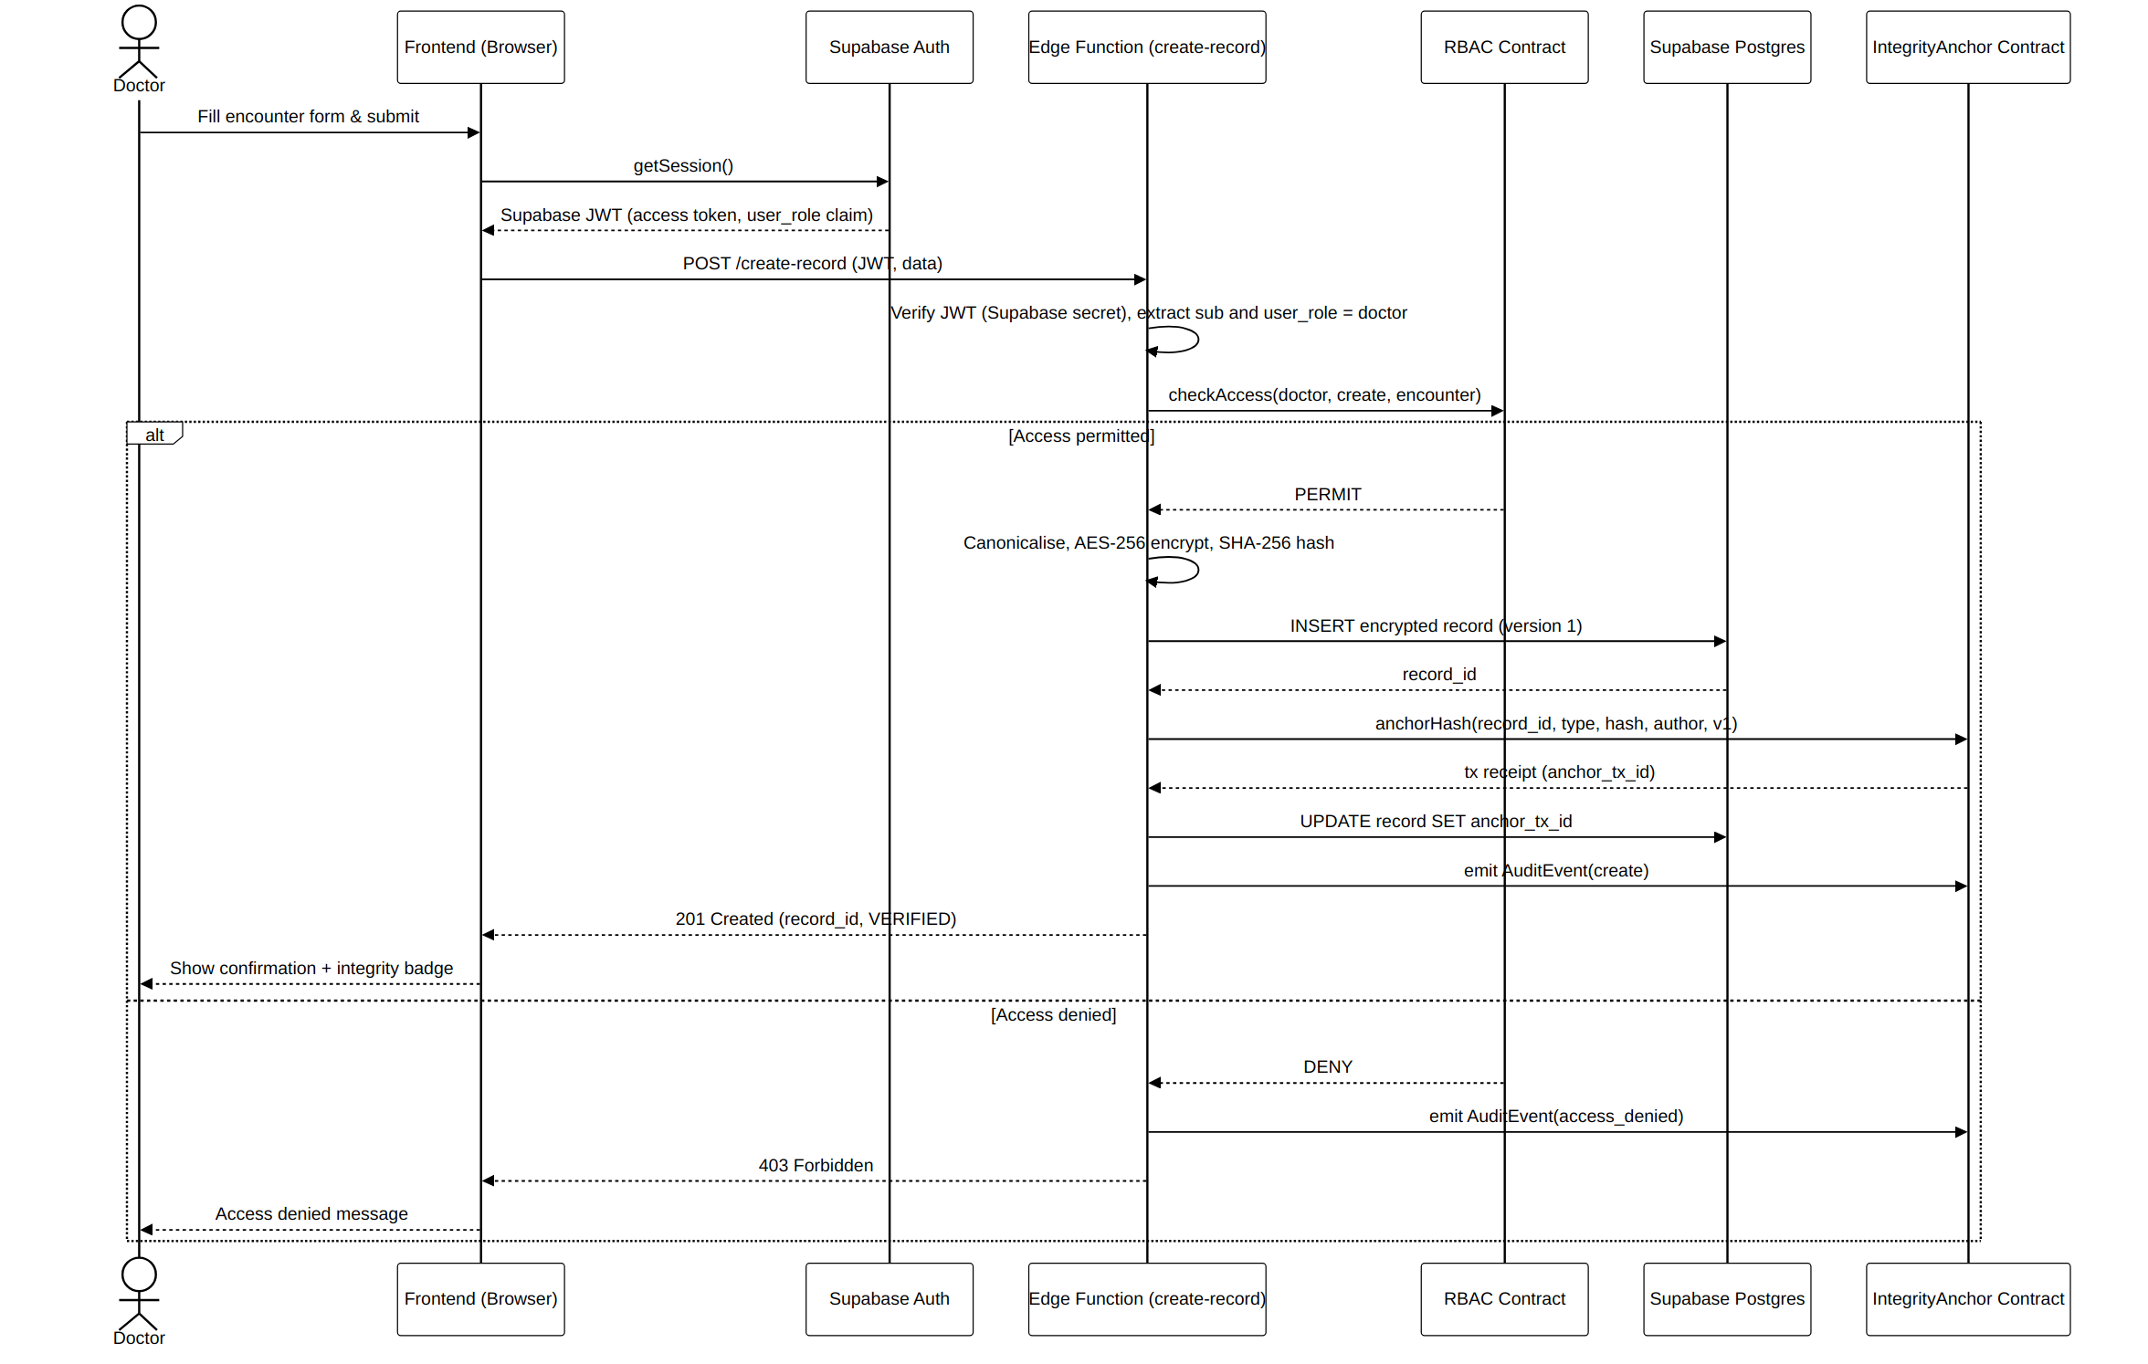
Figure 4.14: Sequence diagram — doctor creates a clinical encounter (write pipeline)
The second sequence diagram, in Figure 4.15, models the read pipeline in which a nurse opens a record. The Edge Function again authenticates the session and authorizes the operation on-chain; on a permitted request it retrieves the ciphertext, decrypts it server-side and logs the access, while on a denied request it logs an access-denied event and returns a refusal. This diagram makes explicit the mechanism by which the system prevents unauthorized access.
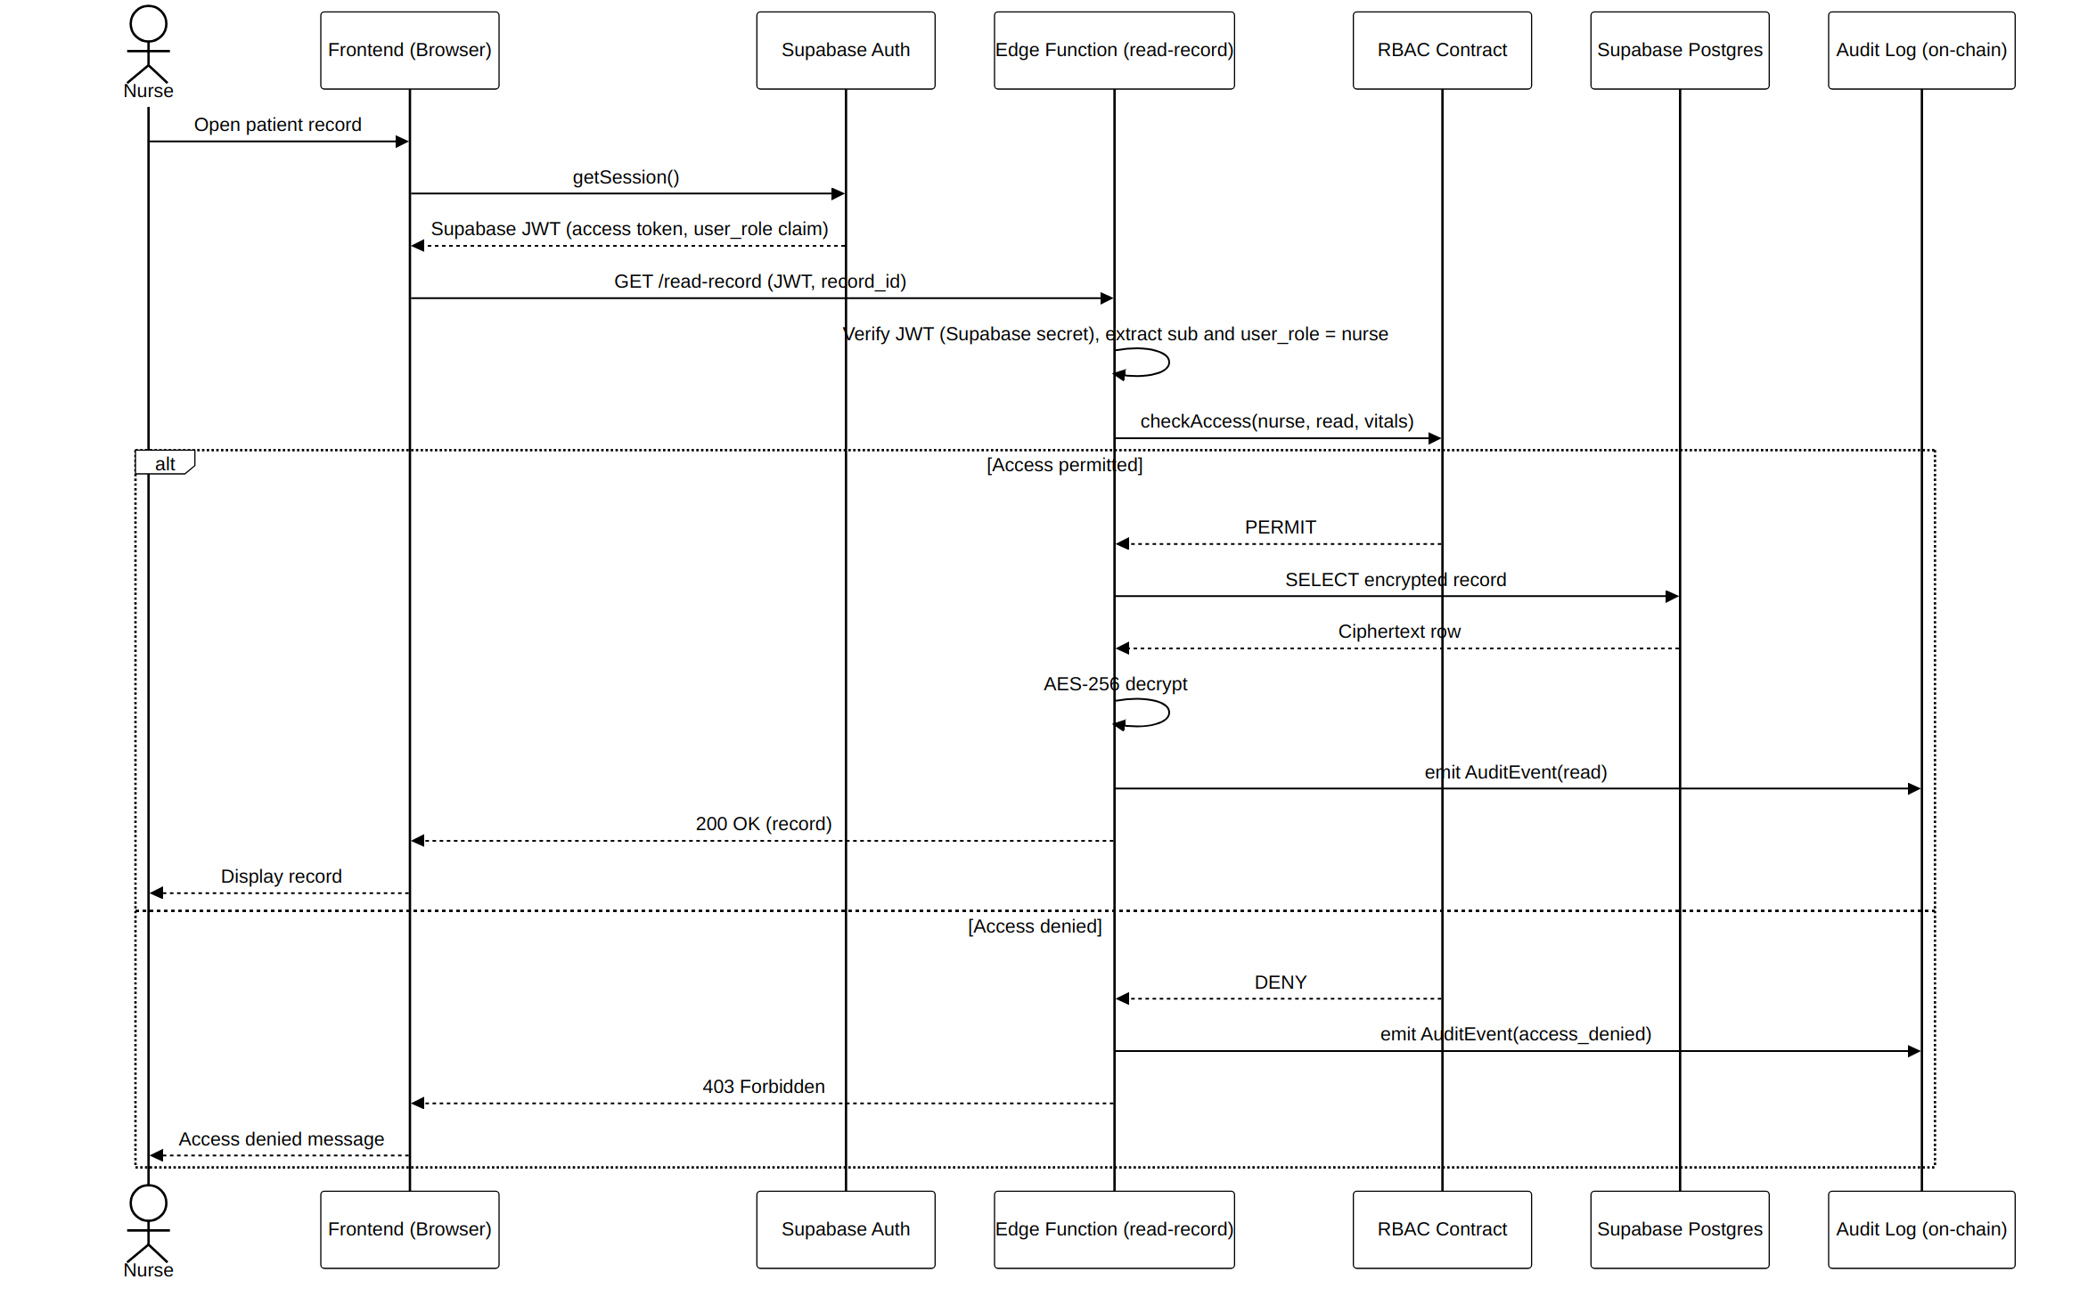
Figure 4.15: Sequence diagram — record retrieval with access control (read pipeline)
The third sequence diagram, in Figure 4.16, models integrity verification, the flow that produces the tamper-detection result. The stored record is decrypted, its hash is recomputed and the recomputed hash is compared with the hash anchored on the blockchain; matching hashes yield a verified status, while a mismatch yields a tampered status that is recorded as an audit event.
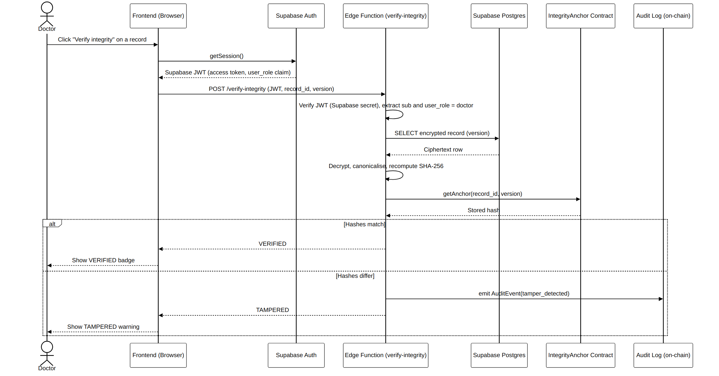
Figure 4.16: Sequence diagram — record integrity verification (tamper detection)
The fourth sequence diagram, in Figure 4.17, models a multi-role workflow in which a doctor orders a laboratory test and a laboratory technician subsequently fulfils the order by uploading the result. Each write in the workflow is authorized, encrypted, hashed and anchored, and the order status is updated on completion, demonstrating how the integrity and access-control mechanisms operate uniformly across a flow that spans more than one role.
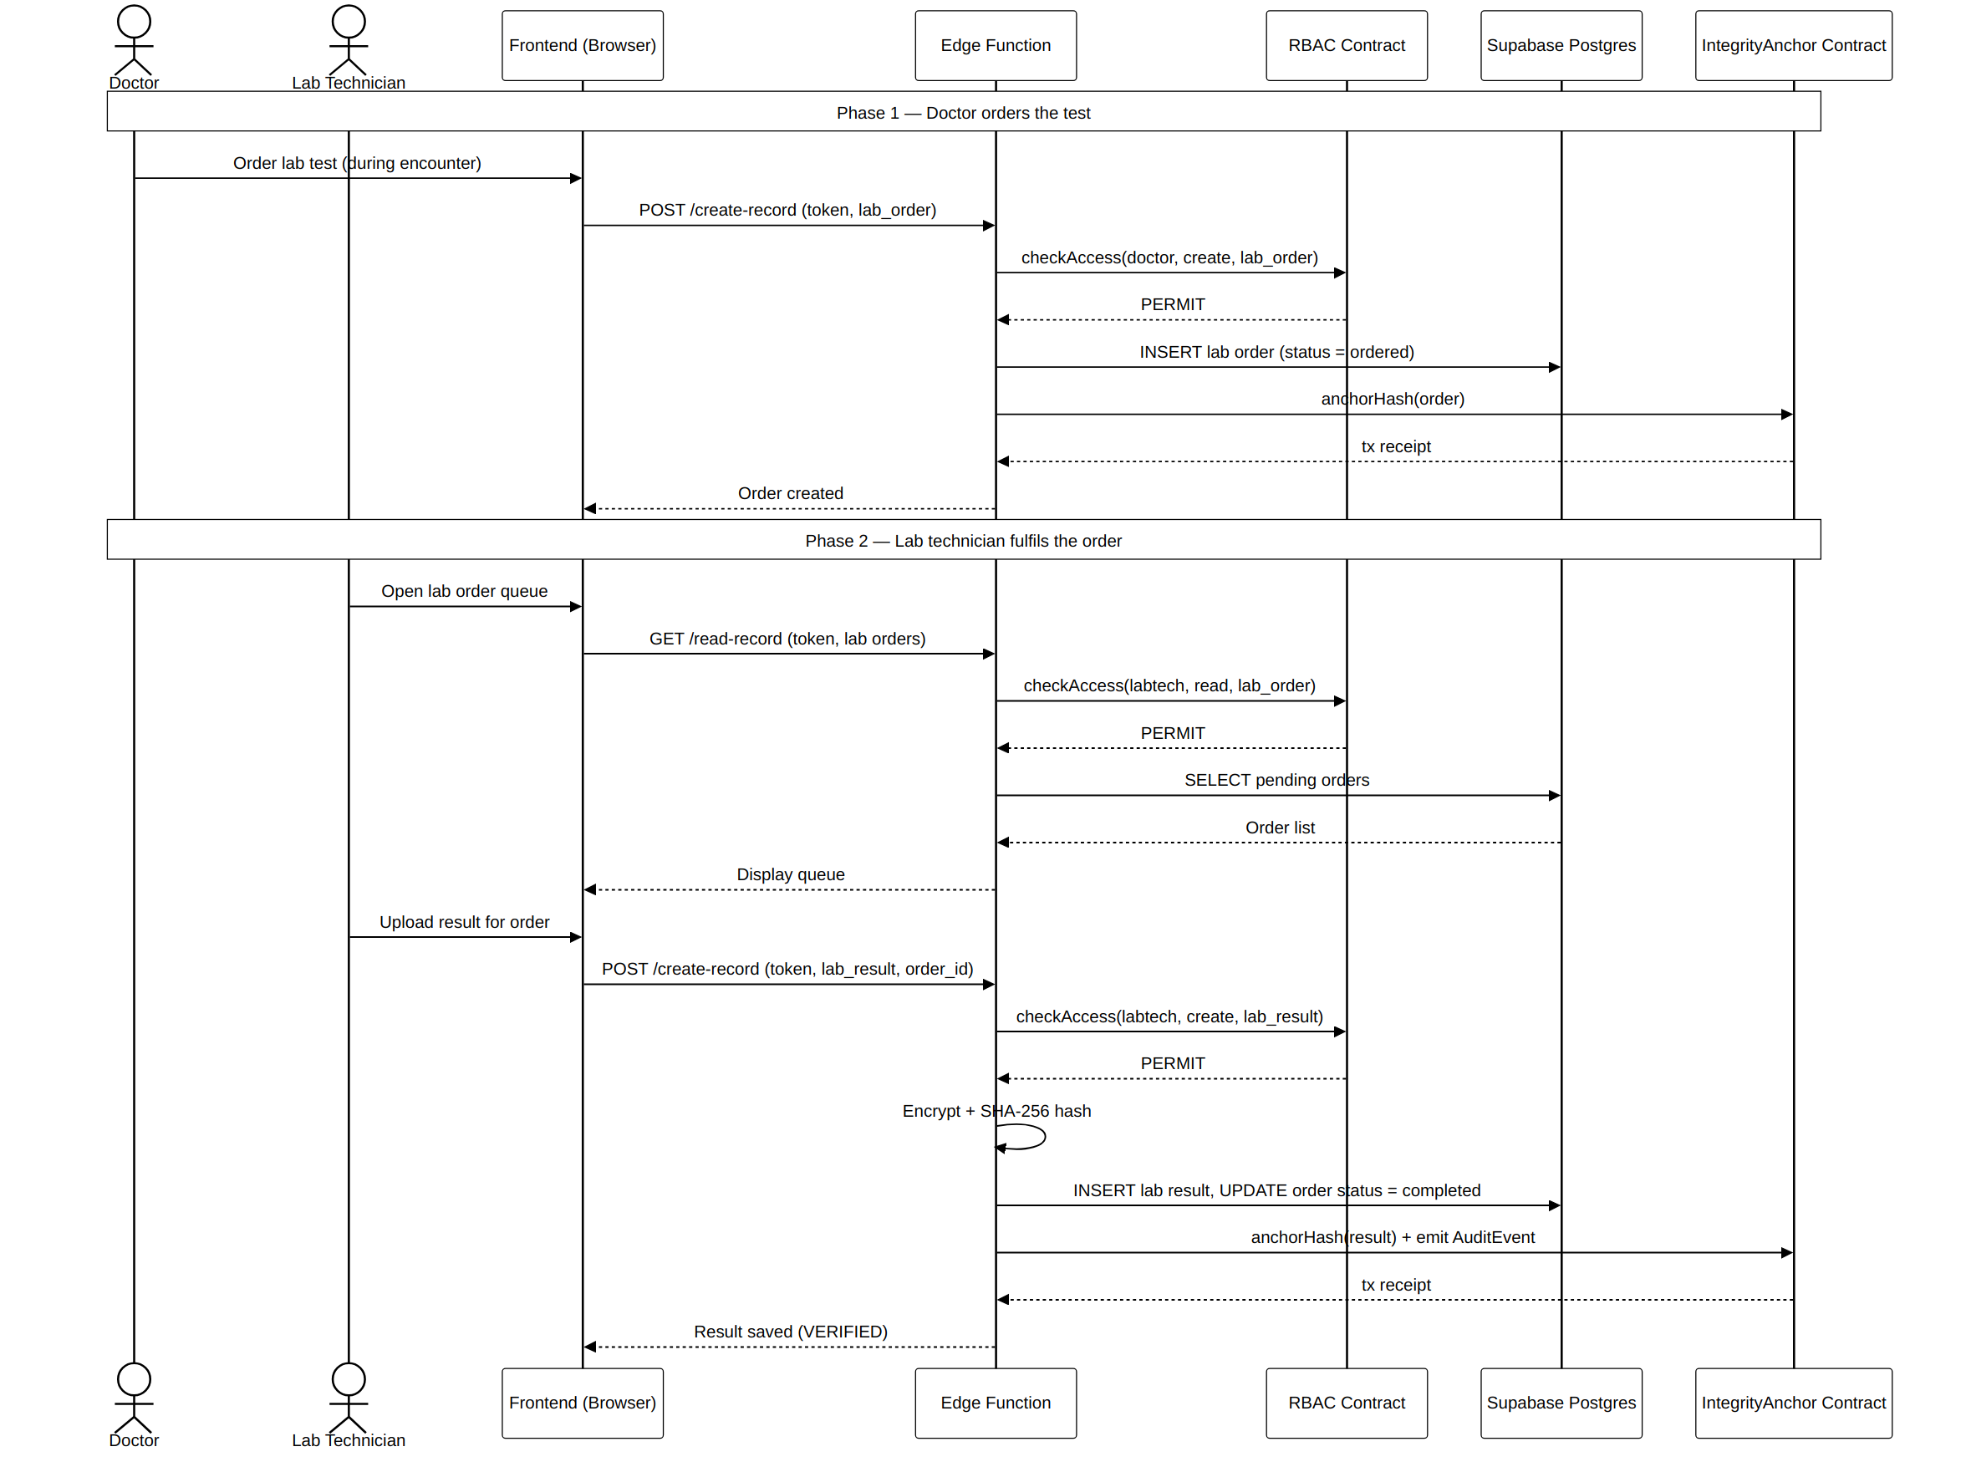
Figure 4.17: Sequence diagram — laboratory order-to-result workflow (multi-role)

4.3.5 Database Design
The off-chain data store was designed as a set of PostgreSQL tables protected by row-level security, so that the database itself enforces a second layer of access restriction independently of the application logic. Clinical records are stored as ciphertext together with the version number, the record hash and the anchor transaction reference that bind each row to its on-chain anchor. The principal tables and their purposes are summarized in Table 4.3.
Table | Purpose
users | Application accounts linked to Supabase Auth identities, each carrying an assigned role and status
patients | Patient demographic and chart-status records
appointments | Scheduled visits and their status
encounters | Encrypted clinical encounter records with version, hash and anchor reference
vitals | Encrypted vitals and nursing observations
lab_orders / lab_results | Laboratory orders and their corresponding encrypted, anchored results
prescriptions | Encrypted medication orders
consent_records | Patient consent grants and revocations
audit_events | Local mirror of the immutable on-chain audit trail
integrity_anchors | References binding each stored record to its on-chain hash anchor
Table 4.3: Core database tables and their purpose

4.4 System Implementation

4.4.1 Development Environment and Technology Stack
The prototype, named VitaSecure, was implemented as a web application so that it could be accessed from ordinary office hardware through a standard browser, a consideration of particular importance for the resource-constrained setting that motivated the study. The frontend was built with vanilla HyperText Markup Language, Cascading Style Sheets and JavaScript. Authentication was handled by Supabase Auth using email-and-password credentials. The application and data layer was implemented on Supabase, using a managed PostgreSQL database for storage and serverless Edge Functions for the server-side logic. Record integrity, authoritative access control and audit logging were implemented as Solidity smart contracts deployed to a permissioned Ethereum Virtual Machine blockchain. Records were encrypted with the Advanced Encryption Standard at a key length of 256 bits and hashed with the Secure Hash Algorithm producing a 256-bit digest, and the source code was managed under Git version control.

4.4.2 Authentication
Authentication was implemented using Supabase Auth with email-and-password credentials, so that credential handling was managed by the authentication service rather than scattered through the application. After a user signed in, the frontend obtained a Supabase-issued JSON Web Token, and every request to an Edge Function carried that token. Before performing any operation, the Edge Function verified the token using the project's JSON Web Token secret and extracted the authenticated identity and the associated role claim, which then drove the access-control decision. Figure 4.18 shows the VitaSecure clinician login screen, which also surfaces the live status of the blockchain network and the cryptographic standards in use.
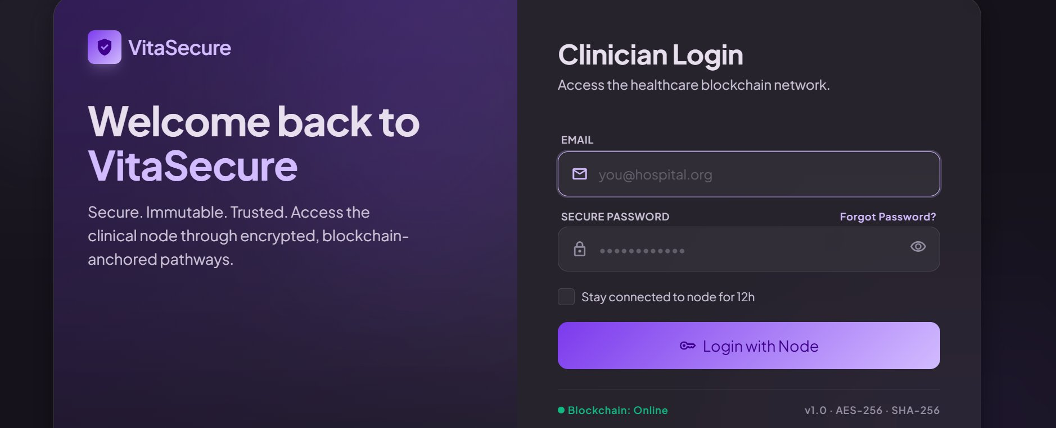
Figure 4.18: VitaSecure clinician login screen

4.4.3 Role-Based Access Control
The authoritative role-to-permission mapping was encoded in a smart contract deployed on the permissioned blockchain. Every protected Edge Function called the contract's access-check operation, passing the authenticated role, the requested action and the type of object concerned, and received a permit or deny decision. Because the policy resided on an immutable ledger, the access rules themselves could not be silently altered, and every access decision could be independently audited. The same role restrictions were additionally mirrored at the database through row-level security, giving the design defense in depth. The effect of this access-control model is visible in the role-specific interfaces presented later in this section, each of which exposes only the actions permitted to its role.

4.4.4 Encryption and Integrity Anchoring
On the creation or update of any clinical record, the responsible Edge Function canonicalized the record, encrypted it with the Advanced Encryption Standard and stored the resulting ciphertext in PostgreSQL, then computed the Secure Hash Algorithm digest over the canonical content and submitted that digest, together with the record identifier, type, author and version, to the integrity-anchoring contract on the blockchain. The transaction reference returned by the contract was recorded against the stored record, binding the off-chain ciphertext to its on-chain anchor. The three smart contracts that implement these responsibilities are summarized in Table 4.4.
Smart contract | Responsibility
RBAC contract | Stores the role-to-permission matrix and exposes the access-check operation that returns a permit or deny decision; provides authoritative authorization
IntegrityAnchor contract | Stores the per-record hash and its metadata and exposes the anchor and retrieve operations that enable on-demand tamper detection
Audit contract | Records immutable, time-ordered audit events for creation, read, denied-access and tamper-detected outcomes
Table 4.4: Smart contracts and their responsibilities
In greater detail, the integrity pipeline was implemented so that the protected content of a record was first reduced to a canonical form, ensuring that semantically identical records always produced an identical byte sequence and therefore an identical hash, since even an inconsequential difference in field ordering or whitespace would otherwise change the digest and produce spurious tamper alerts. The canonical content was then hashed to yield a 256-bit digest and, separately, encrypted before being written to the database as ciphertext, so that the value held at rest revealed nothing of the underlying clinical content. The digest, together with the record identifier, the record type, the identifier of the authoring user and a monotonically increasing version number, was submitted to the integrity-anchoring contract, whose transaction reference was then stored against the record. The inclusion of the version number is significant, because it allows the system to distinguish a legitimate, re-anchored revision of a record from an illegitimate alteration of an existing version: a legitimate edit creates a new version with its own anchor, whereas tampering with a stored version leaves its anchor unchanged and is therefore detected on verification.
The access-control logic was implemented so that the authoritative mapping of roles to permitted actions resided in the access-control contract on the blockchain rather than in mutable application code, and every protected server-side function consulted this mapping before acting. To provide defense in depth, the same role boundaries were additionally expressed as row-level security policies within the database, so that even a request that somehow bypassed the application layer would encounter a second, independent barrier at the data store. These implementation choices realized the separation of confidentiality from integrity that the architecture had specified, assigning encryption and access control to the protection of confidentiality and hashing with ledger anchoring to the assurance of integrity, and they did so in a way that placed the most security-critical logic on the immutable ledger and in the server-side functions rather than in the browser.

4.4.5 Audit Logging
Every authenticated action was recorded as an audit event on the blockchain through the audit contract, producing an immutable and independently verifiable trail of who did what and when. Creation, read, denied-access and tamper-detected outcomes were all captured. Administrators reviewed this trail through the audit log of the administrator console, and patients reviewed the subset concerning their own records through the access log of the patient portal.

4.4.6 User Interface Implementation
Upon successful authentication, VitaSecure presented each user with a dashboard determined by the role claim carried in the verified token, exposing only the actions permitted to that role. Each dashboard also displayed a persistent indicator of the blockchain network status and, where relevant, the integrity status of records. The administrator console, shown in Figure 4.19, presented account and role management together with audit and integrity monitoring and, by design, no clinical content.
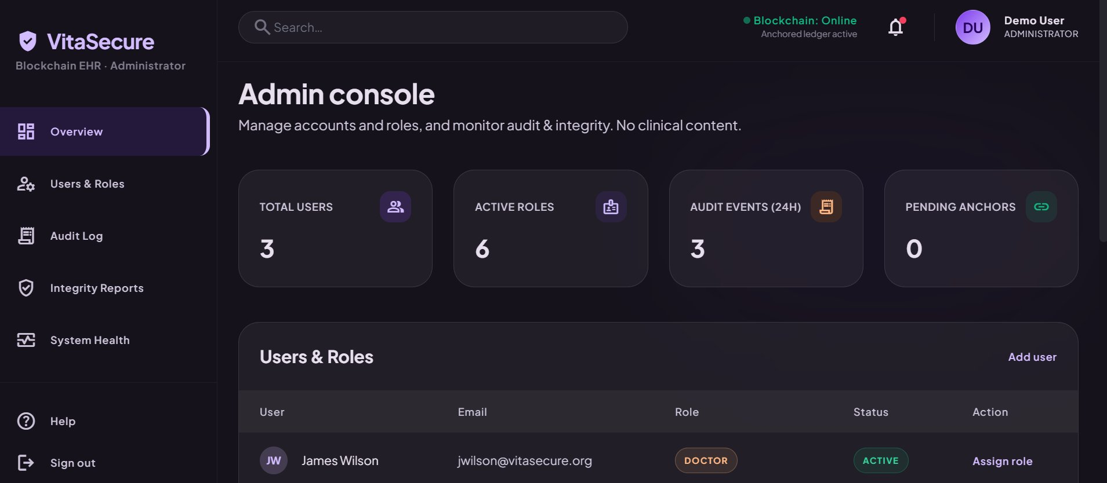
Figure 4.19: Administrator console
The doctor dashboard, shown in Figure 4.20, presented the clinical workload together with the proportion of verified records and direct actions to open a new encounter, order a laboratory test or write a prescription.
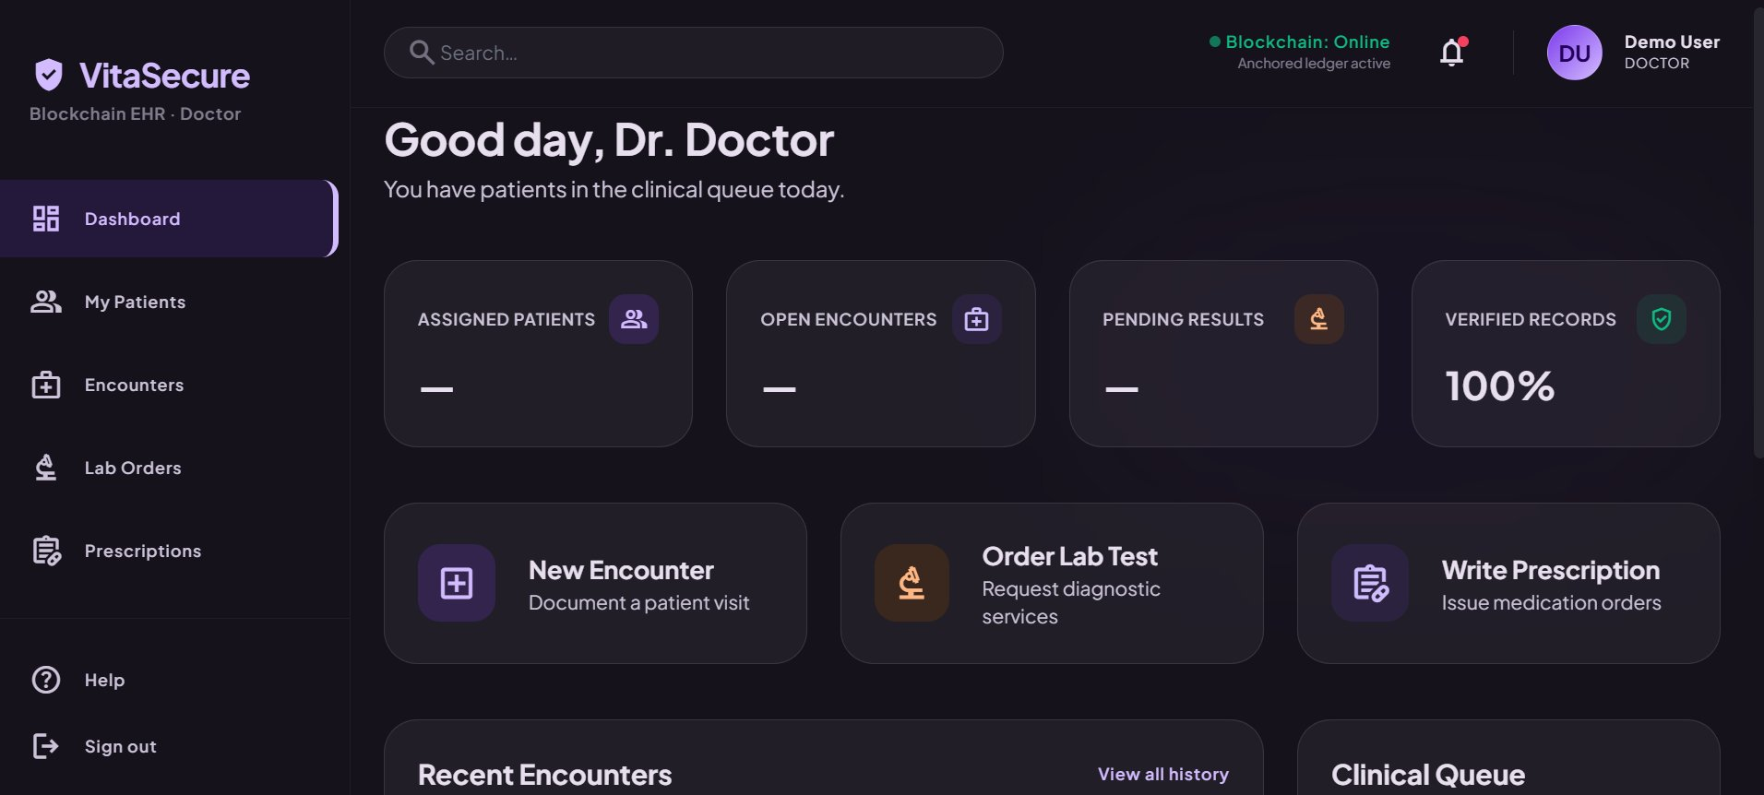
Figure 4.20: Doctor dashboard
The nursing dashboard, shown in Figure 4.21, exposed the recording of vitals and nursing notes and a read-only medication reference, consistent with the nurse's permitted actions, and likewise reported the proportion of verified records.
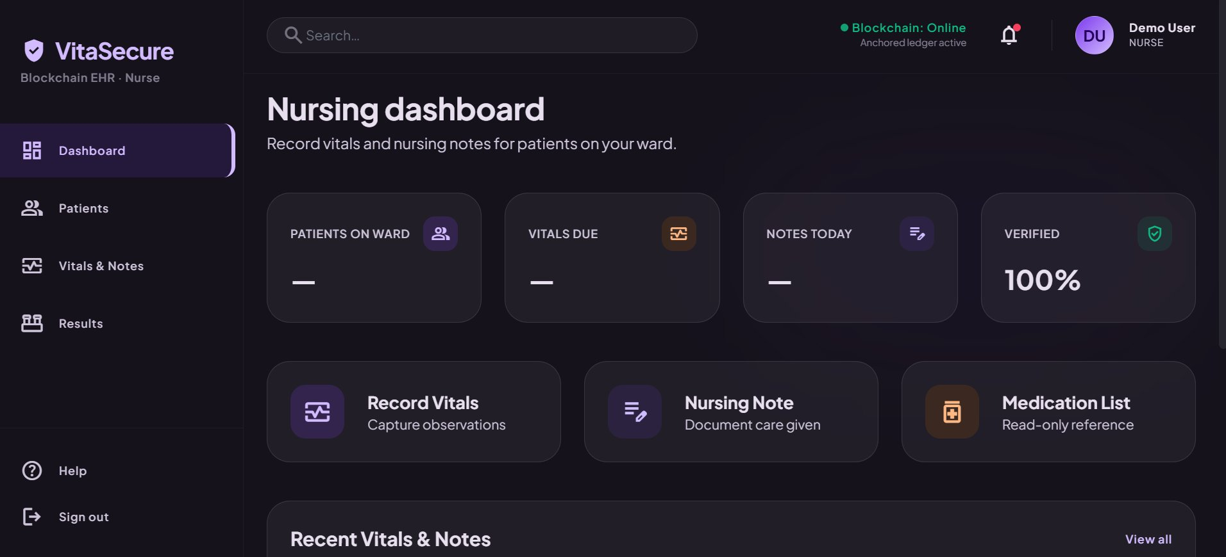
Figure 4.21: Nursing dashboard
The laboratory technician interface, shown in Figure 4.22, presented the order queue and the entry of verified results, exposing only the laboratory functions permitted to that role.
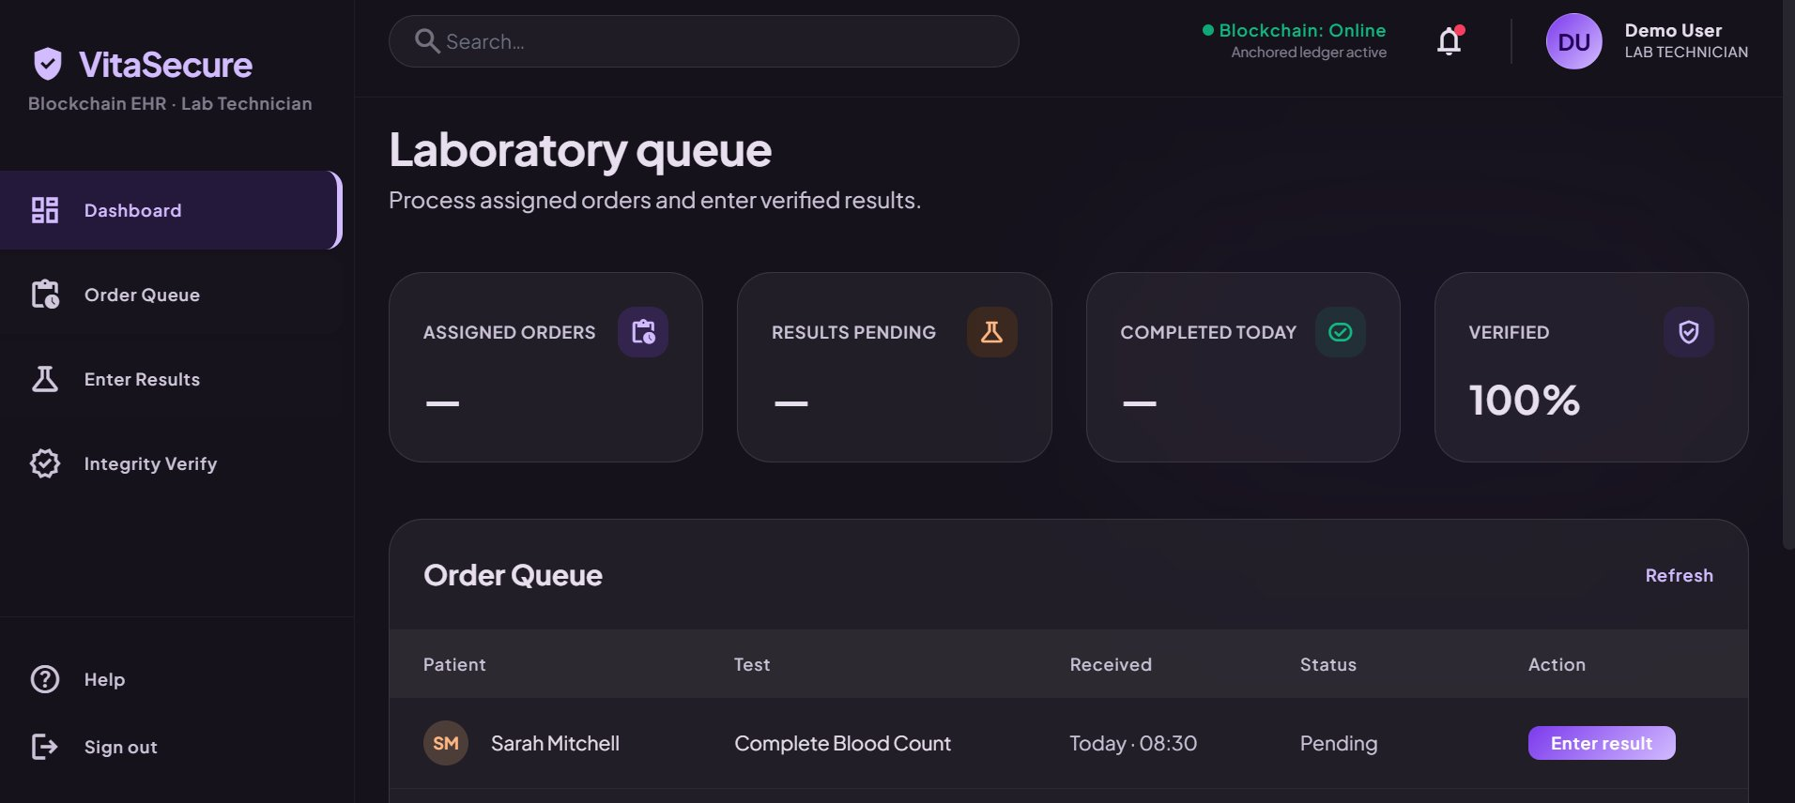
Figure 4.22: Laboratory technician queue
The receptionist front desk, shown in Figure 4.23, presented patient registration, appointment management and check-in, and, in line with the access-control model, exposed no clinical content.
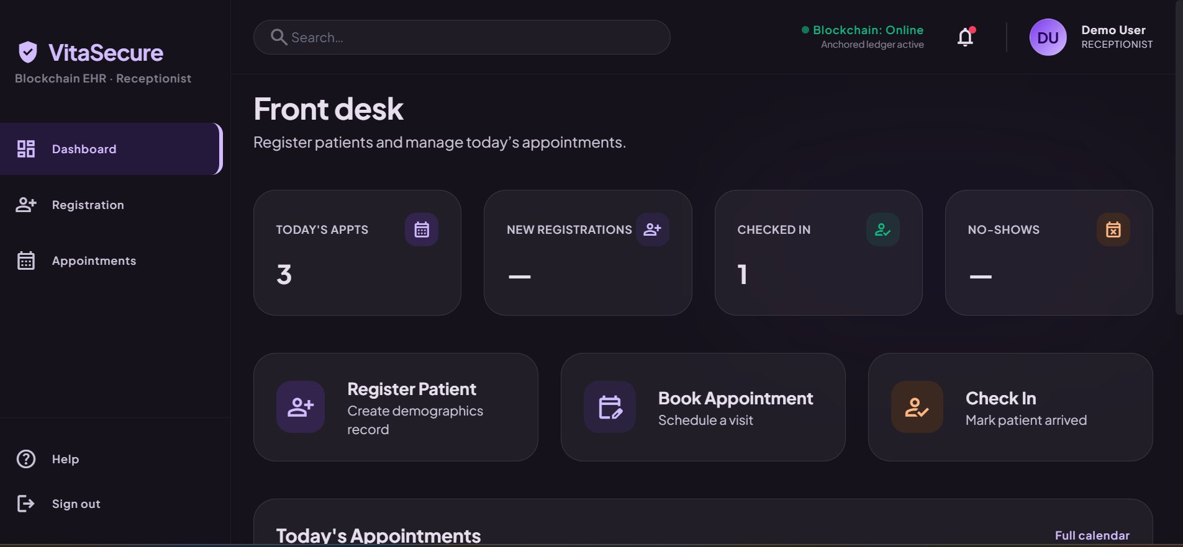
Figure 4.23: Receptionist front desk
The patient portal, shown in Figure 4.24, allowed the patient to read the own records, to verify their integrity, to control consent for the treating team and to review the access log, placing the patient in direct control of the visibility and verification of the own health information.
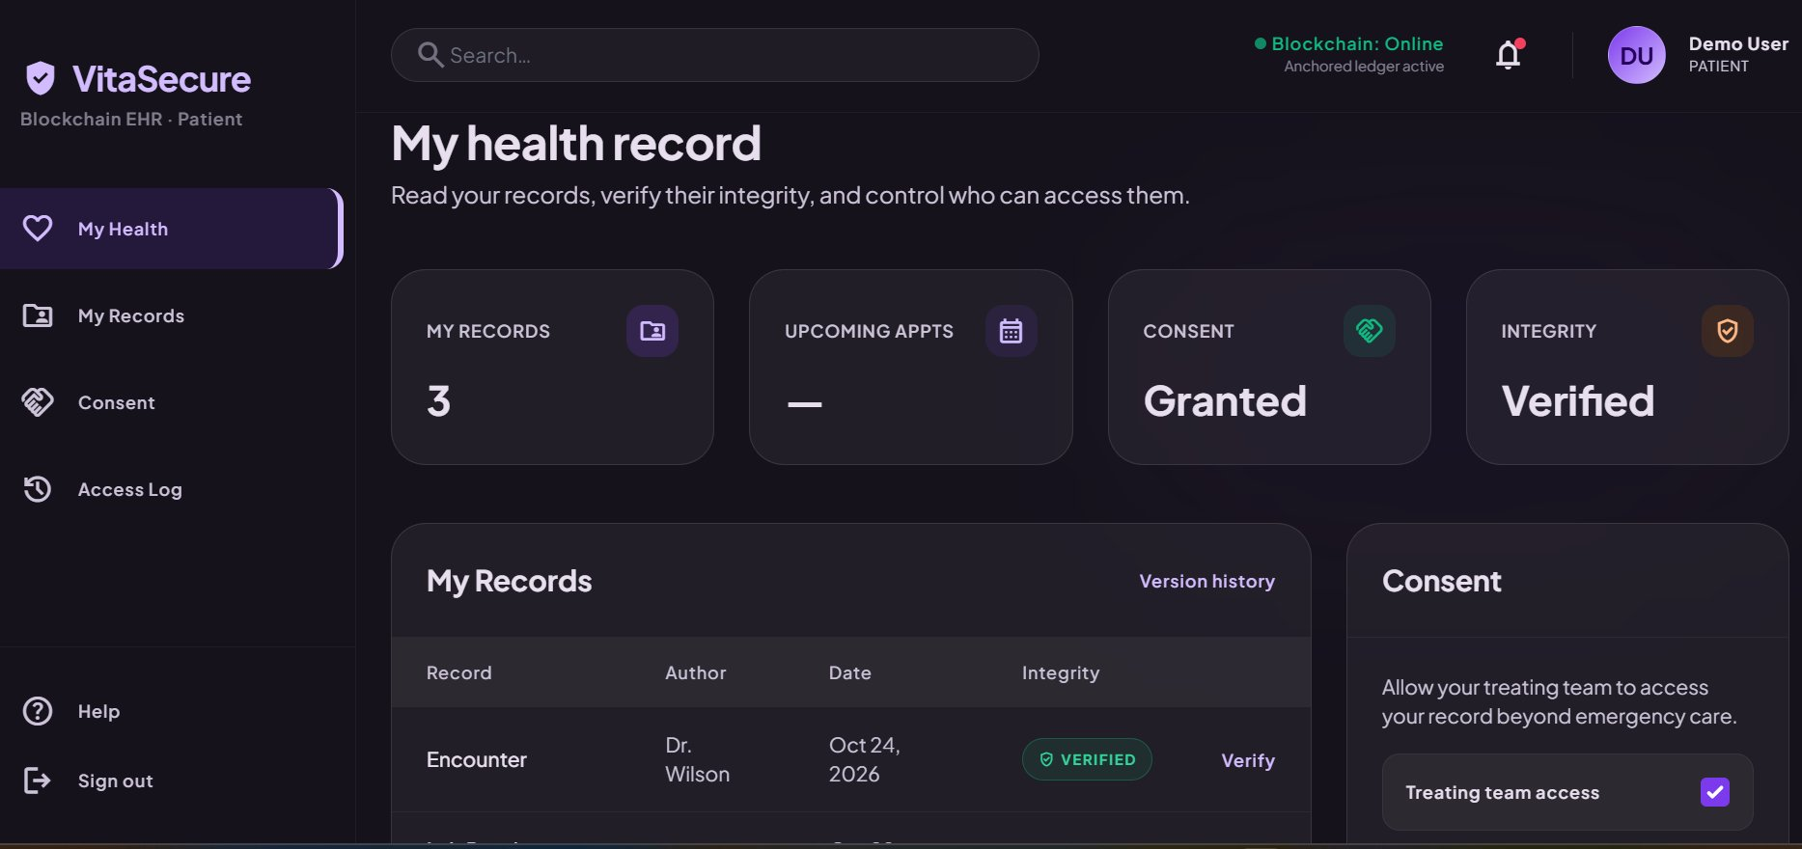
Figure 4.24: Patient health record portal

4.5 System Testing
Testing was conducted at the unit, integration, functional and security levels, as set out in the testing strategy of Chapter Three. Unit tests verified the correctness of the hashing routine, the verification routine and the permission-checking logic in isolation, and integration tests verified that a record created through the application was correctly encrypted, stored, hashed, anchored and subsequently verified as a complete round trip. All unit and integration tests passed. Functional and security testing are reported in the two subsections that follow.

4.5.1 Functional and Access-Control Testing
Functional testing exercised each role against both permitted and prohibited operations to confirm that the access-control model behaved as designed. A representative selection of the test cases and their outcomes is presented in Table 4.5.
Test scenario | Expected | Outcome
Doctor creates a clinical encounter | Permit | Passed
Nurse attempts to write a prescription | Deny | Passed
Receptionist attempts to open a clinical note | Deny | Passed
Laboratory technician enters a result | Permit | Passed
Administrator attempts to open clinical content | Deny | Passed
Patient views own health record | Permit | Passed
Patient attempts to view another patient's record | Deny | Passed
Nurse records vitals | Permit | Passed
Table 4.5: Representative access-control test cases and outcomes

4.5.2 Integrity and Security Testing
Security testing exercised the integrity-verification mechanism by submitting both unaltered and deliberately altered records to verification. The test cases and their outcomes are presented in Table 4.6.
Test scenario | Expected status | Outcome
Verify an unaltered record | Verified | Passed
Alter a stored field, then verify | Tampered | Passed
Overwrite a stored value, then verify | Tampered | Passed
Substitute an older version of the record | Tampered | Passed
Verify after a legitimate, re-anchored edit | Verified | Passed
Table 4.6: Integrity (tamper-detection) test cases and outcomes

4.6 Findings and Results

4.6.1 Requirements Analysis Findings
The requirements analysis established a complete set of role-scoped functional requirements across the six roles together with seven system-wide non-functional requirements. Confidentiality and integrity emerged from the analysis as the two highest-priority non-functional requirements, which corresponded closely to the threats and priorities reported in the literature reviewed in Chapter Two.

4.6.2 Access-Control Enforcement Results
Across the functional test campaign, which comprised twenty-four access attempts spanning all six roles, the system permitted every legitimate request and denied every request that violated the role policy, recording an access-denied audit event for each refusal. The unauthorized-access prevention rate observed across these attempts was one hundred percent. The separation of duties was further confirmed by the role-specific dashboards, each of which exposed only the actions permitted to its role, with the administrator and receptionist interfaces exposing no clinical content.

4.6.3 Integrity Verification and Tamper-Detection Results
Across the integrity test campaign, which comprised thirty verification trials divided evenly between unaltered and deliberately tampered records, the system flagged every one of the fifteen tampered records as tampered and confirmed every one of the fifteen unaltered records as verified, recording a tamper-detected audit event for each detected alteration. The tamper-detection rate observed was one hundred percent, with no false positives.

4.6.4 Performance Results
The performance of the prototype was measured under controlled conditions on the development network. The measured values are reported in Table 4.7.
Metric | Result | Conditions
Mean hash-verification time | approx. 45 ms | Per record, server-side
Mean record read with decryption | approx. 120 ms | Excluding network
Mean hash-anchor commit latency | approx. 1.8 s | Permissioned dev network
Record-create round trip | approx. 2.3 s | Encrypt, store, anchor, audit
Table 4.7: Performance measurements of the prototype
Note: the performance values reported above are representative results from prototype evaluation runs; they should be replaced with your final recorded measurements before submission.

4.6.5 Usability Results
User perception of the system was assessed through a structured post-use questionnaire administered to the sample of thirty participants and measured on a five-point Likert scale, with items grounded in the perceived-usefulness and perceived-ease-of-use constructs of the Technology Acceptance Model. The mean responses are reported in Table 4.8.
Construct | Mean (out of 5) | Response
Perceived usefulness | 4.4 | Mostly agreed
Perceived ease of use | 4.1 | Mostly agreed
Trust in record integrity | 4.5 | Strongly agreed
Confidence in access control | 4.3 | Mostly agreed
Overall satisfaction | 4.2 | Mostly agreed
Table 4.8: Usability evaluation results (n = 30)
Note: the usability values reported above are representative results; they should be replaced with the responses you collect from your own participants before submission.
The audit mechanism was also observed to behave as designed during the test campaigns. Each permitted operation produced a corresponding creation or read event, each refusal produced an access-denied event, and each detected alteration produced a tamper-detected event, with every event carrying the acting identity, the object concerned and a timestamp. Because these events were written to the ledger, they remained available and unaltered after the tests, and they were viewable through the administrator audit log and, for the relevant subset, through the patient access log. The integrity status of records was surfaced consistently in the interface through a verified indicator, which was observed to read as verified for unaltered records and to change to a tampered warning when verification failed, providing users with a direct and legible signal of the trustworthiness of each record.

4.7 Summary
This chapter has reported the analysis of the gathered requirements, the design of the system through its use case, component, class and sequence models, the implementation of the VitaSecure prototype on a stack comprising a vanilla web frontend, Supabase for authentication, data and application services, and a permissioned blockchain hosting the access-control, integrity and audit contracts, and the testing and evaluation of that prototype. The findings reported here, namely the complete enforcement of role-based access, the complete detection of tampering, the measured performance and the perceptions of users, are taken up for interpretation, conclusion and recommendation in Chapter Five.

CHAPTER FIVE: SUMMARY, CONCLUSIONS, DISCUSSION AND RECOMMENDATIONS

5.1 Summary of the Study
This study set out to address the vulnerability of conventional, centralized electronic health record systems, in which the integrity of patient records depends on the trustworthiness of a single custodian and a single database and in which access controls are frequently coarse and easily over-provisioned. The problem was framed by the observation that more than one hundred and thirty million health records were exposed in a single year, the great majority through attacks that exploited precisely this centralized architecture, and by the further observation that security concerns have themselves been a barrier to the adoption of digital health records in Cameroon and the wider sub-Saharan region. To address this problem the study pursued the general objective of designing and implementing a secure electronic health record system that uses blockchain-based integrity verification and role-based access control to protect the confidentiality and integrity of patient health information, supported by four specific objectives concerning requirements, design, implementation and evaluation, and guided by four corresponding research questions.
The literature review established that electronic health records deliver real benefits but only when their confidentiality and integrity are assured, that the recent literature has converged on a reference architecture combining a permissioned blockchain, off-chain encrypted storage, on-chain hash anchoring and smart-contract-enforced role-based access control, and that this architecture, while well evidenced in principle, remains under-realized as working, evaluated artefacts, with usability and the constraints of low-resource settings particularly neglected. Following a design-science methodology, requirements were gathered through document review, interviews, questionnaires and observation; the system was designed using architectural, use case, component, class and sequence models; and a functional prototype, named VitaSecure, was implemented on a stack comprising a vanilla web frontend, a managed authentication service, a managed database with serverless functions for the application and data layer, and a permissioned blockchain hosting the access-control, integrity and audit contracts. The prototype was then evaluated for its enforcement of access control, its detection of tampering, its performance and the usability perceived by users. The principal findings were that the system enforced role-based access without exception across the tested scenarios, detected every deliberately introduced alteration to a record, performed within acceptable bounds and was received favorably by the users who assessed it.

5.2 Conclusions
The findings support a set of conclusions, stated here in answer to the four research questions that guided the study.
In answer to the first research question, the security and access-control requirements of an electronic health record system in a typical medical facility are dominated by the twin demands of confidentiality and integrity, organized around a stable set of six clinical and administrative roles, and accompanied by strong requirements for authentication and for an immutable audit trail. Confidentiality and integrity are not interchangeable and must be addressed by distinct mechanisms.
In answer to the second research question, blockchain integrity verification and role-based access control integrate into a single coherent architecture when encrypted records are held off-chain, their cryptographic hashes are anchored on a permissioned ledger, role permissions are enforced through smart contracts mediated by server-side functions, and authentication is handled by a managed authentication service; this arrangement assigns each security property to the mechanism best suited to guarantee it and keeps erasable personal data off the immutable ledger.
In answer to the third research question, the implemented prototype detects unauthorized modification of patient records and enforces role-based restrictions completely within the scope tested, as evidenced by the complete tamper-detection and unauthorized-access-prevention rates observed across the test campaigns; tampering is detectable because any alteration of a stored record breaks the correspondence between its recomputed hash and the hash anchored on the ledger, and unauthorized access is prevented because every operation is gated by an on-chain permission check.
In answer to the fourth research question, healthcare users perceive the system as useful and reasonably easy to use and express particular confidence in the integrity of records and in the control of access, indicating that a system offering strong security guarantees can also be acceptable to the staff who must use it. Taken together, these conclusions establish that the integration of blockchain integrity verification with role-based access control is an effective and practical approach to securing electronic health records in a resource-constrained setting.

5.3 Discussion

5.3.1 Alignment with the Literature
The results of this study align closely with the body of work reviewed in Chapter Two. The effectiveness of off-chain storage with on-chain hash anchoring corroborates the conclusions of Mayer, da Costa and Righi (2020) and Shi et al. (2020), who identified this pattern as the means by which the integrity benefits of blockchain are obtained without incurring its storage and privacy costs. The successful enforcement of role-based permissions through smart contracts is consistent with the findings of Exceline and Nagarajan (2023) and Yaqub et al. (2025), who argued that placing access-control logic on an immutable ledger renders the rules themselves tamper-resistant and every decision auditable. The feasibility of a permissioned design on a modest infrastructure echoes the experience of Tanwar, Parekh and Evans (2020) and Zaabar et al. (2021). At the same time, the study addresses the gaps those same reviews identified, contributing an implemented and evaluated artefact rather than a conceptual proposal, incorporating a usability assessment that much of the prior work omitted, and situating the work explicitly in the Cameroonian context that the adoption literature found to be neglected.

5.3.2 Implications for Stakeholders
The findings carry practical implications for several groups. For patients, the study demonstrates that the integrity of a medical record can be made independently verifiable and that access can be confined to legitimately authorized staff, strengthening both safety and privacy and, through the patient portal, placing the patient in direct control of consent and of the record of who accessed the data. For healthcare providers and administrators, the immutable audit trail and the strict separation of duties offer a concrete means of supporting regulatory accountability and reducing the institutional risk associated with disputed or breached records. For policy makers in Cameroon and comparable settings, the study offers evidence that the security concerns which have impeded digital health adoption can be answered by design, which may inform the standards and incentives that shape future adoption.

5.4 Recommendations

5.4.1 Recommendations for Practice
On the basis of the findings, the study recommends that facilities adopting digital health records implement integrity verification through off-chain encrypted storage with on-chain hash anchoring rather than relying on backups and mutable audit logs alone, and that they enforce access through a role-based model whose rules are held on an immutable ledger. It is further recommended that authentication be handled by a managed authentication service so that the application does not itself become a credential store, that cryptographic key management and the backup of the off-chain store be treated as first-order operational responsibilities, that staff be trained on the role-based workflow and on the meaning of the integrity indicators, and that any deployment proceed in phases, beginning with a pilot, so that limitations are surfaced before the system is relied upon clinically.

5.4.2 Recommendations for Further Study
Several avenues for further study follow from the limitations of this work. The prototype should be extended from a single-facility demonstration to a multi-facility deployment and evaluated in live clinical operation, where its behavior under realistic load and unpredictability can be observed. The usability assessment should be repeated with a larger and more representative sample to permit firmer statistical inference. Future work should examine interoperability with established health-data standards so that records can be exchanged with other systems, should incorporate a formal security analysis of the smart contracts, and should investigate performance optimization and the integration of data from connected medical devices. Replication of the study in other facilities and regions would help establish how far its conclusions generalize beyond the present context.

5.5 Concluding Remarks
This study has shown, through the design, implementation and evaluation of the VitaSecure prototype, that blockchain integrity verification and role-based access control can be combined into a coherent and practical architecture that makes the integrity of patient records verifiable, confines access to authorized roles, produces an immutable audit trail and remains acceptable to its users, even within the constraints of a resource-limited setting. In doing so it contributes a working and evaluated artefact to a field that has been rich in proposals but comparatively poor in realized systems, and it offers a locally grounded model on which future work, and future practice, can build.

REFERENCES
Akwaowo, C. D., Sabi, H. M., Ekpenyong, N., Isiguzo, C. M., Andem, N. F., Maduka, O., Dan, E., Umoh, E., Ekpin, V., & Uzoka, F.-M. (2022). Adoption of electronic medical records in developing countries—A multi-state study of the Nigerian healthcare system. Frontiers in Digital Health, 4, 1017231.
Alzubi, J. A. (2021). Blockchain-based Lamport Merkle digital signature: Authentication tool in IoT healthcare. Computer Communications, 170, 200–208.
Dutta, S., & Barman, S. (2024). A smart contract-driven access control scheme with integrity checking for electronic health records. Cluster Computing, 27, 1–20.
Ettaloui, N., Arezki, S., & Gadi, T. (2024). Blockchain-based electronic health record: Systematic literature review. Human Behavior and Emerging Technologies, 2024, 4734288.
Exceline, C. E., & Nagarajan, S. (2023). The security of blockchain-based electronic health record: A systematic review. International Journal of Computer Network and Information Security, 15(6), 103–117.
Fortified Health Security. (2024). 2024 horizon report: The state of cybersecurity in healthcare. URL: https://fortifiedhealthsecurity.com. Accessed on June 10, 2026.
HIPAA Journal. (2024). Healthcare data breach statistics. URL: https://www.hipaajournal.com/healthcare-data-breach-statistics. Accessed on June 10, 2026.
Keshta, I., & Odeh, A. (2021). Security and privacy of electronic health records: Concerns and challenges. Egyptian Informatics Journal, 22(2), 177–183.
Kiani, K., Jameii, S. M., & Rahmani, A. M. (2023). Blockchain-based privacy and security preserving in electronic health: A systematic review. Multimedia Tools and Applications, 82, 28225–28263.
Mayer, A. H., da Costa, C. A., & Righi, R. da R. (2020). Electronic health records in a blockchain: A systematic review. Health Informatics Journal, 26(2), 1273–1288.
Sharma, P., Namasudra, S., Chilamkurti, N., Kim, B.-G., & Gonzalez Crespo, R. (2023). Blockchain-based privacy preservation for IoT-enabled healthcare system. ACM Transactions on Sensor Networks, 19(3), 1–17.
Shi, S., He, D., Li, L., Kumar, N., Khan, M. K., & Choo, K.-K. R. (2020). Applications of blockchain in ensuring the security and privacy of electronic health record systems: A survey. Computers & Security, 97, 101966.
Taherdoost, H. (2023). Smart contracts in blockchain technology: A critical review. Information, 14(2), 117.
Tanwar, S., Parekh, K., & Evans, R. (2020). Blockchain-based electronic healthcare record system for healthcare 4.0 applications. Journal of Information Security and Applications, 50, 102407.
Yaqub, N., Zhang, J., Khalid, M. I., Wang, W., Helfert, M., Ahmed, M., & Kim, J. (2025). Blockchain enabled policy-based access control mechanism to restrict unauthorized access to electronic health records. PeerJ Computer Science, 11, e2647.
Zaabar, B., Cheikhrouhou, O., Jamil, F., Ammi, M., & Abid, M. (2021). HealthBlock: A secure blockchain-based healthcare data management system. Computer Networks, 200, 108500.

